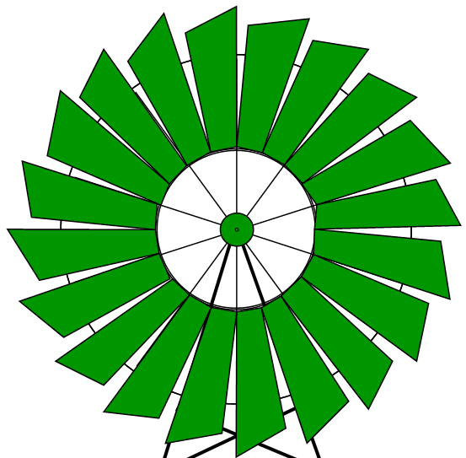
Western Mathematics
2013 Year 10
Half Yearly Examination
Mathematics Course
Solutions
Short Answer Questions
1.
2. | 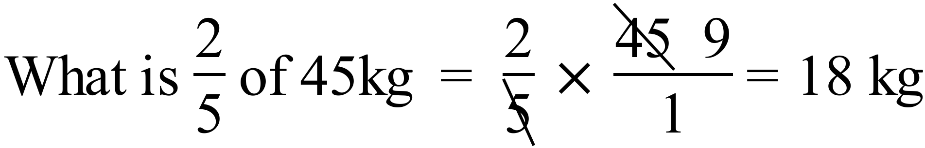
3. | 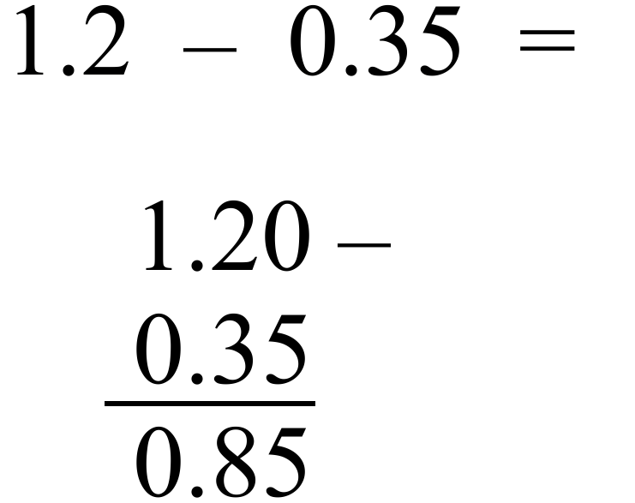
4. | 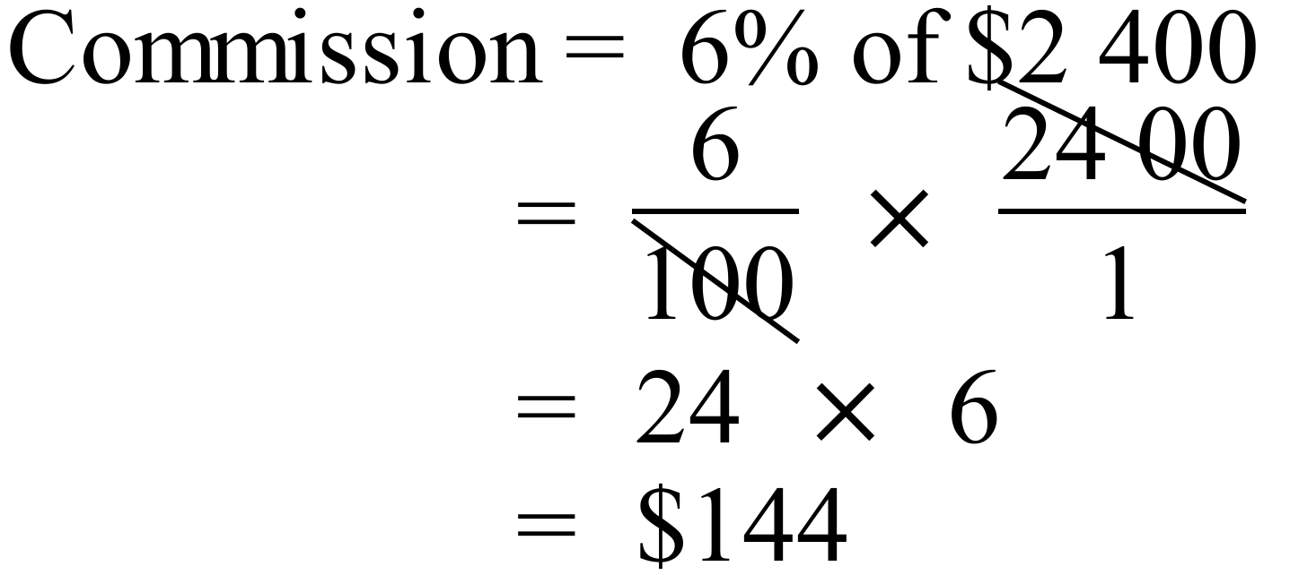
5. | 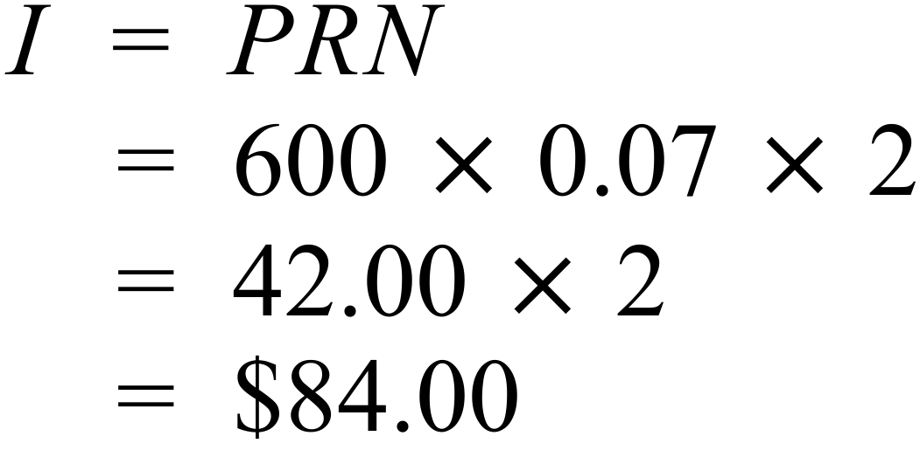
6. | 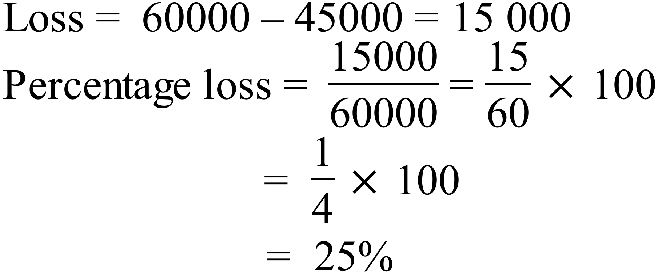
7. | 4.5 kilograms : 750 grams = 4500 g : 750 g  = 450 : 75  = 18 : 3  = 6 : 1
8. | What is the value of x in the diagram?  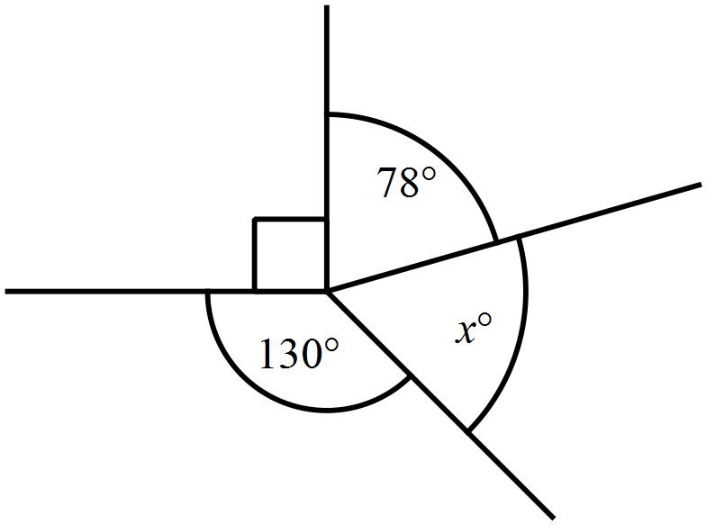  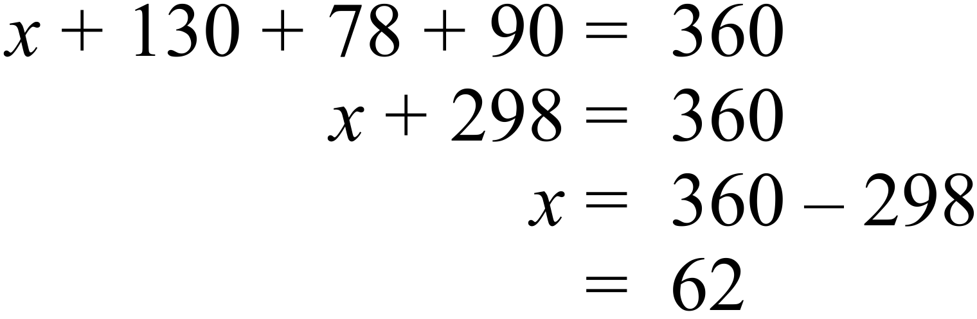
9. | The base angles xº are equal.  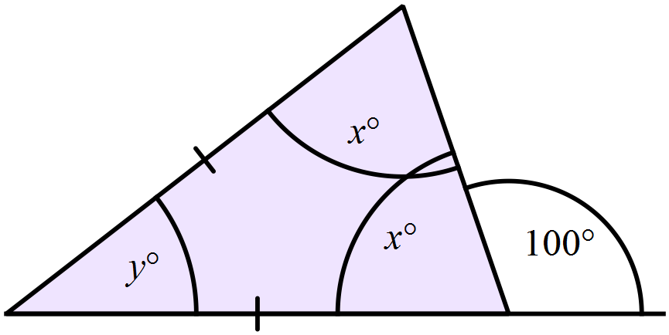  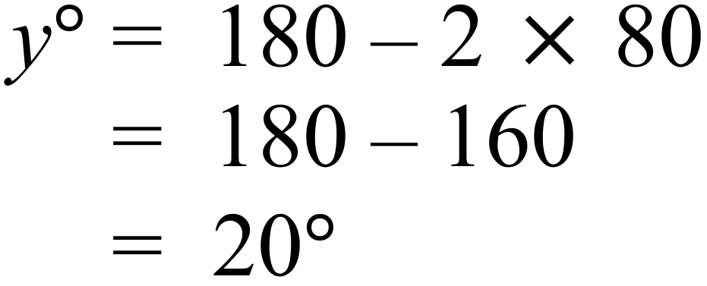
10. | The name is a RHOMBUS
   | Property | Yes /No
   | All sides equal | Y
   | All angles equal | N
   | Diagonals are equal | N
   | Diagonals intersect at right angles | Y
   | Axes of symmetry | Y (2)
11. | 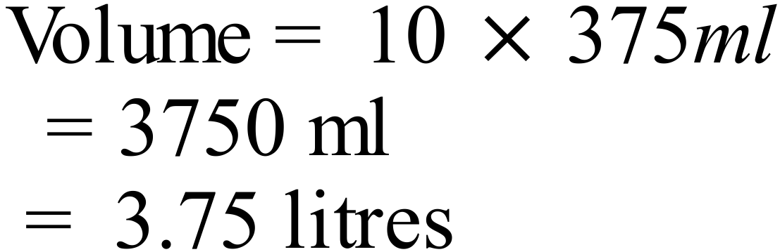
12. | 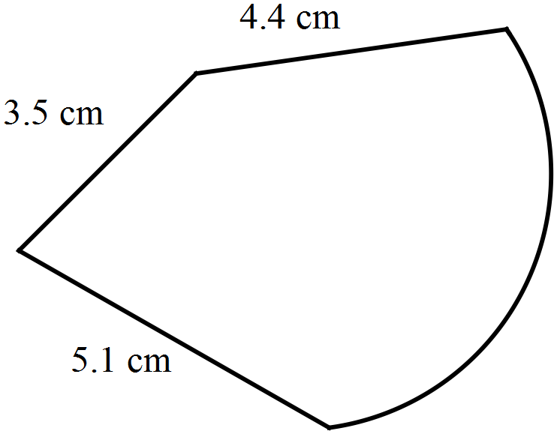  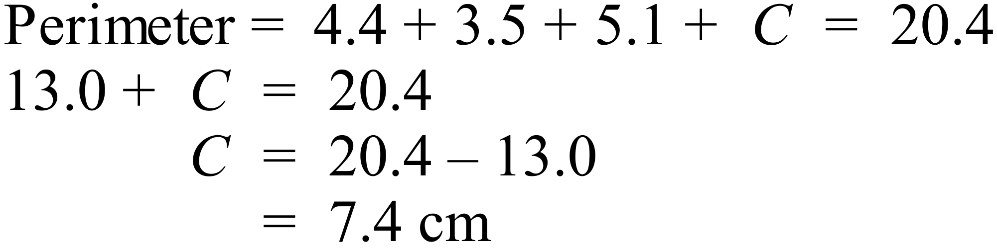
13. | 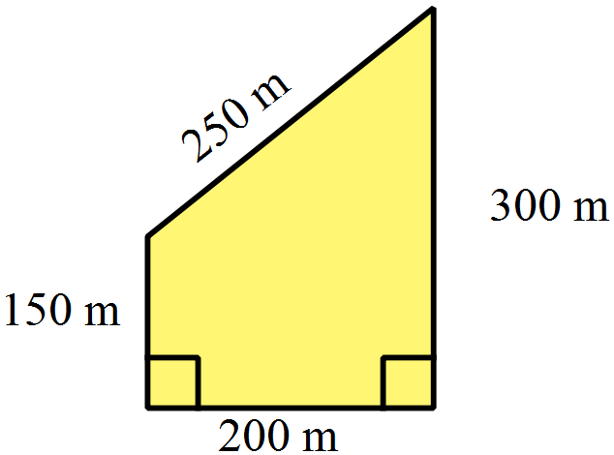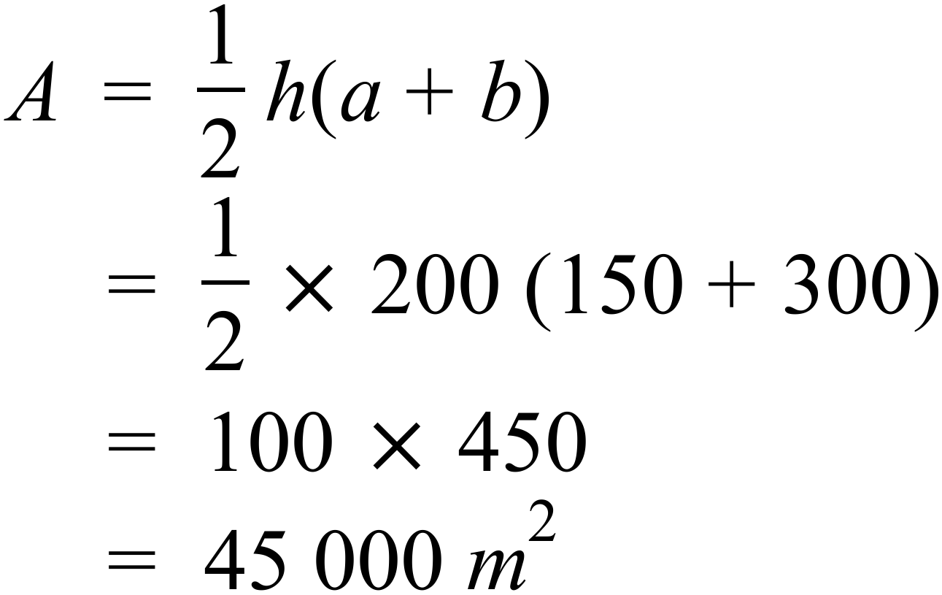
14. | 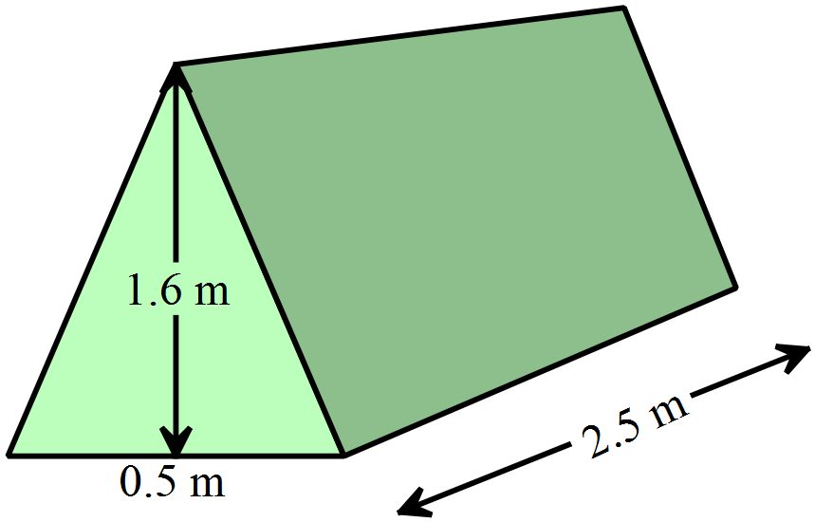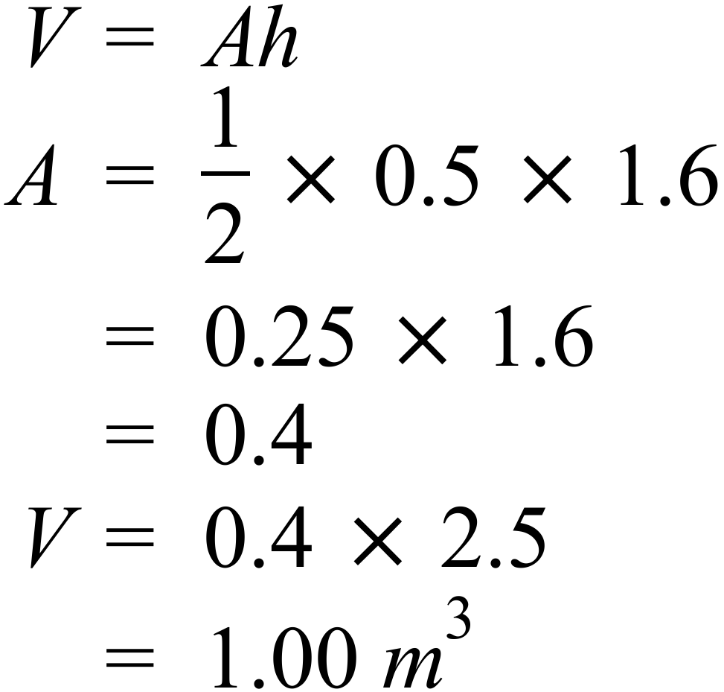
15. | 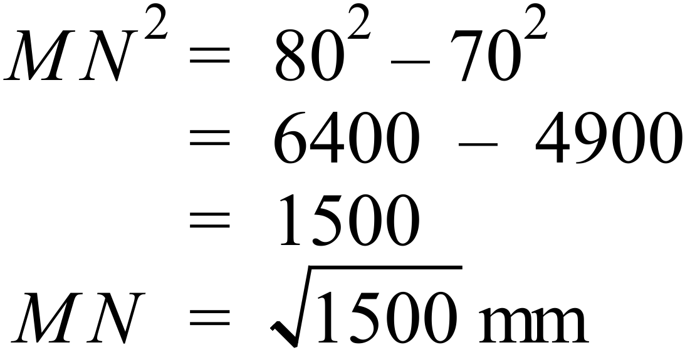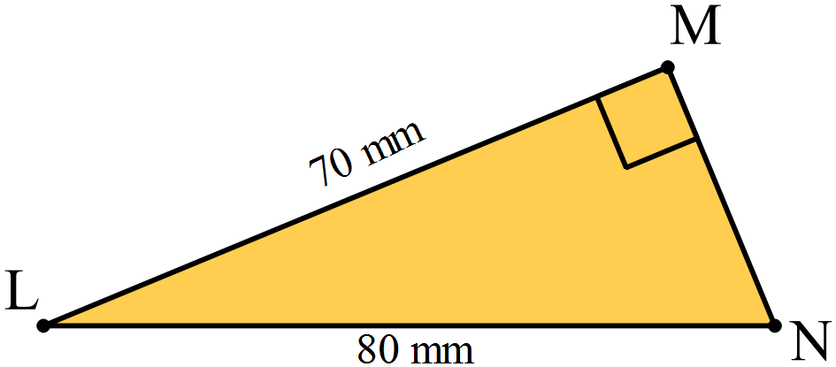
16.
17. | 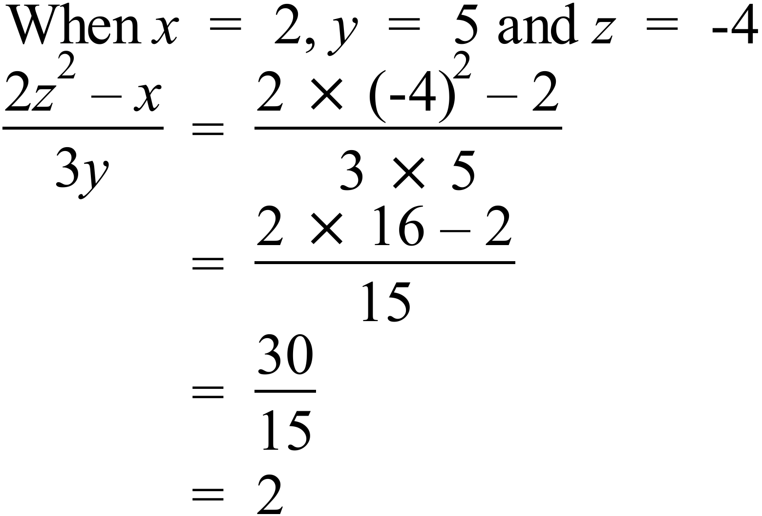
18. | 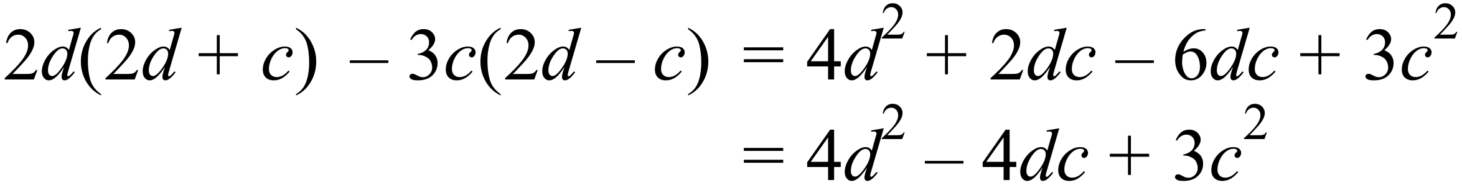
19. | 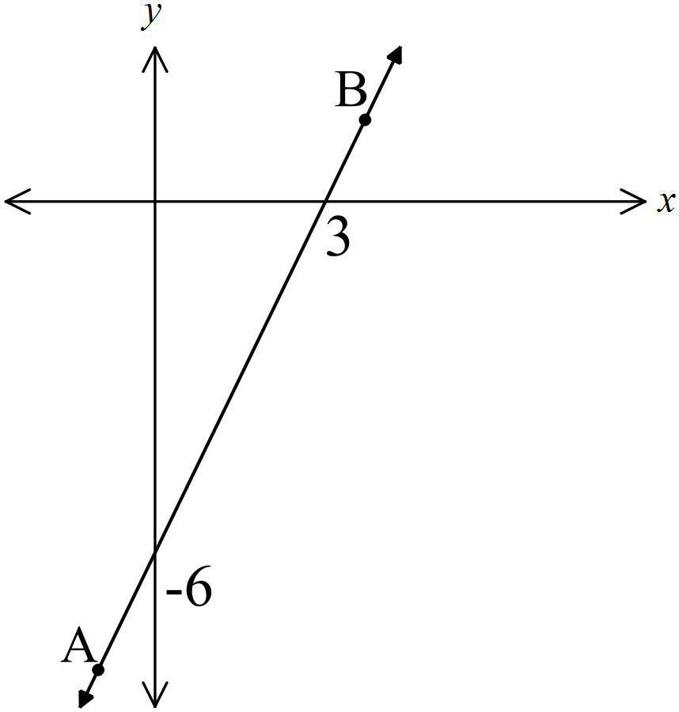 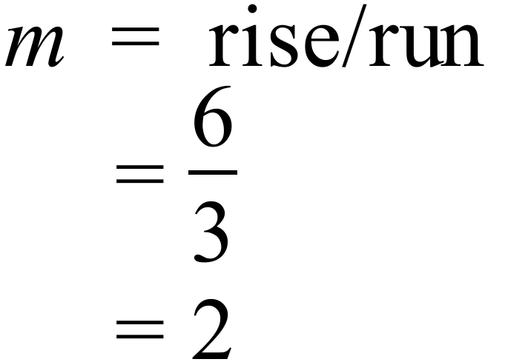 OR 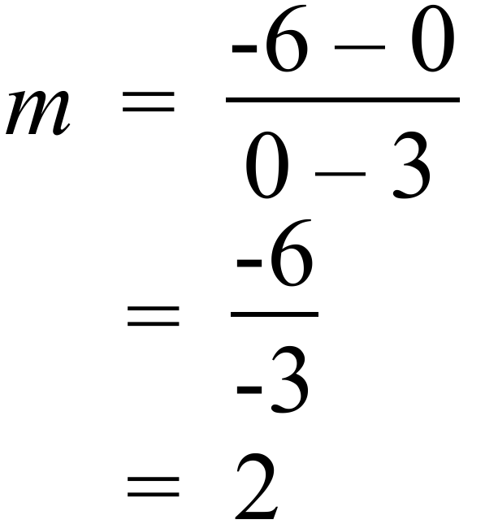
20. | 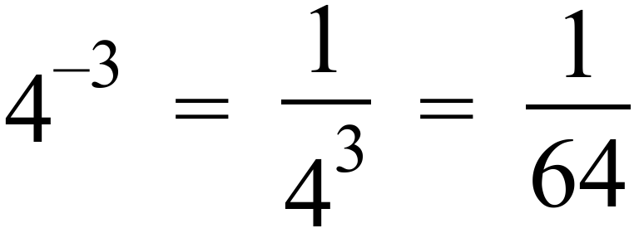
21. | Solve 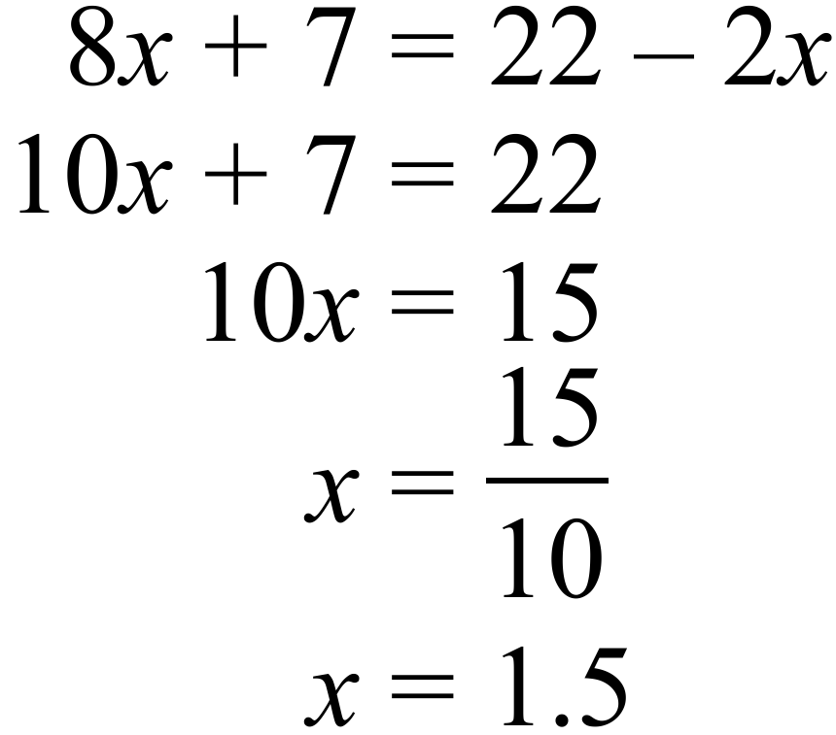
22. | 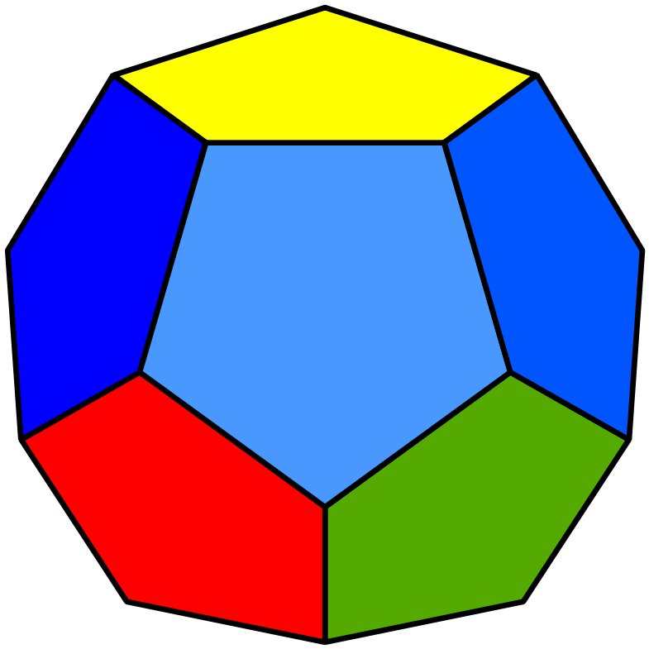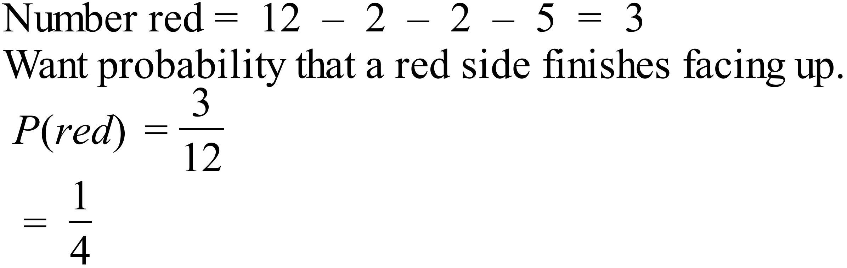
23. | Dance and Games are both 60º which is 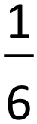 of his time.
24. | James spent 6 hours a week playing sport = 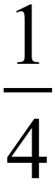 of total.  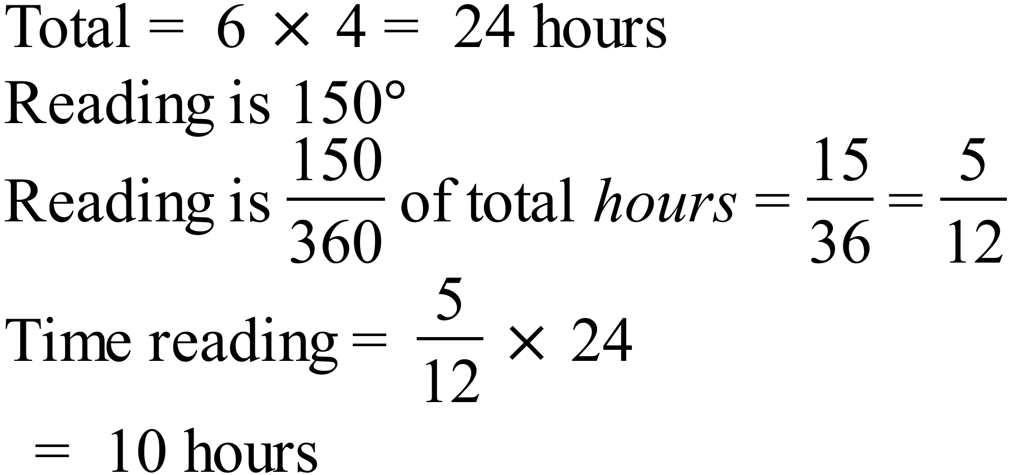
25. | From 20 scores median between 10th and 11th so between 2 and 3. Median = 2.5
   |  |  | O
  O |  | O | O
  O |  | O | O | O
  O | O | O | O | O
  O | O | O | O | O | O |  |  | O
  0 | 1 | 2 | 3 | 4 | 5 | 6 | 7 | 8

Multiple Choice Questions
 | 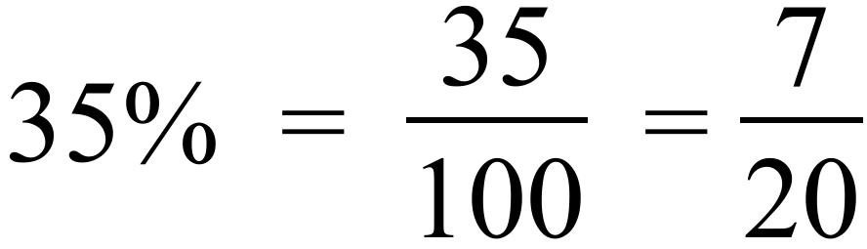 | D
 | 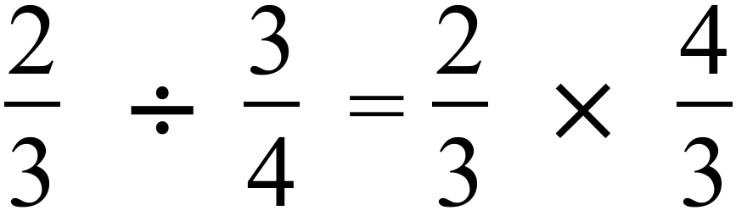 | B
 | 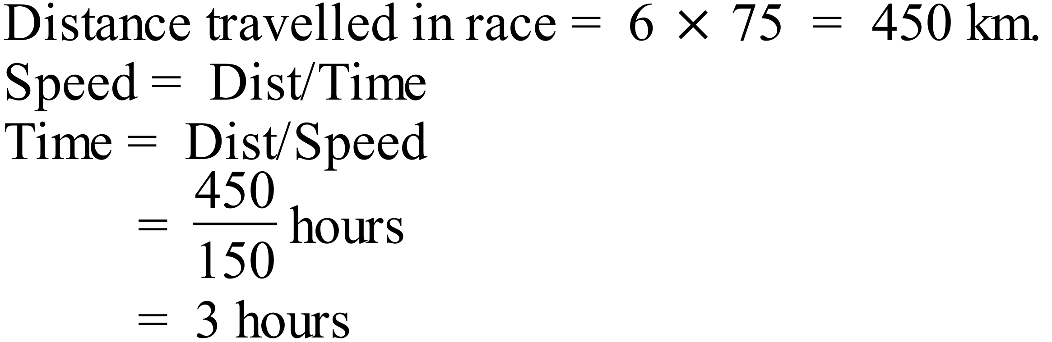 | D
 | 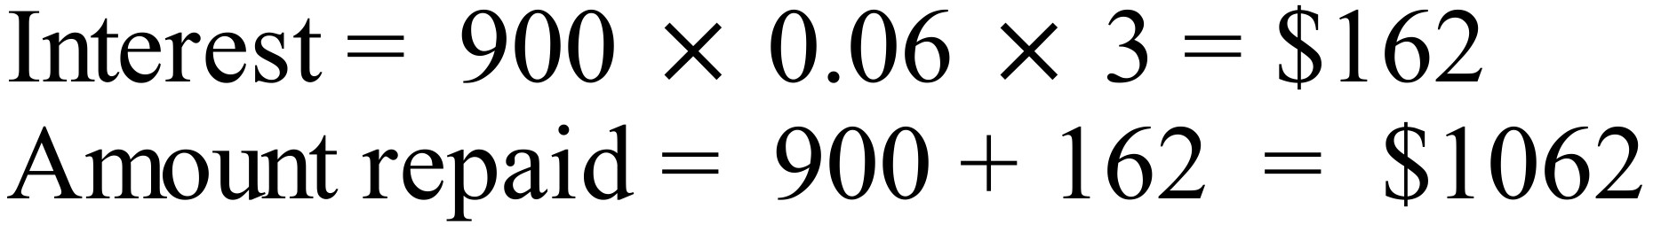 | C
 | 40 hours normal plus 8 hours at time ½  =40 + 12 = 52 hours at normal rates | C
 | 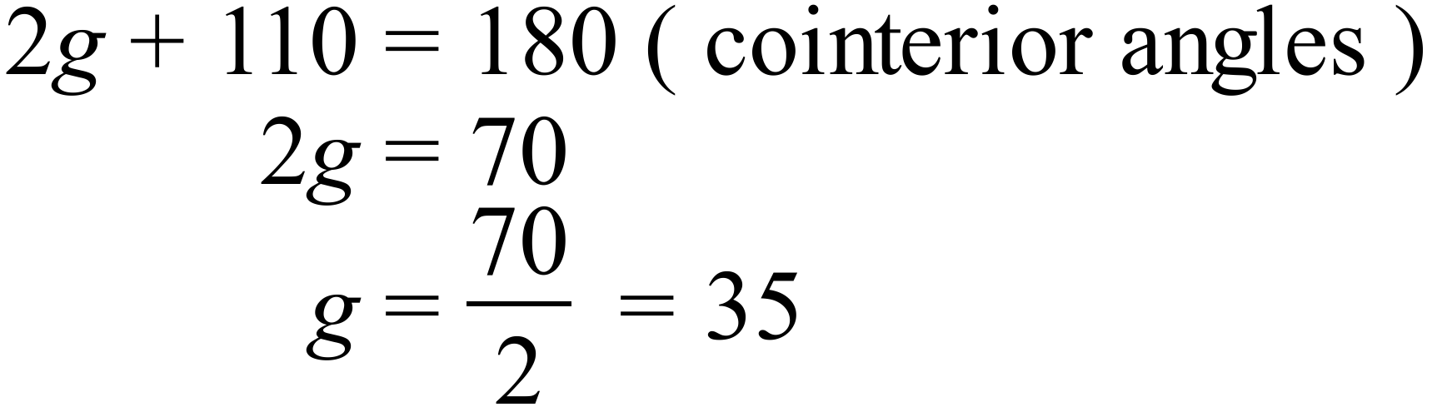 | B
 | 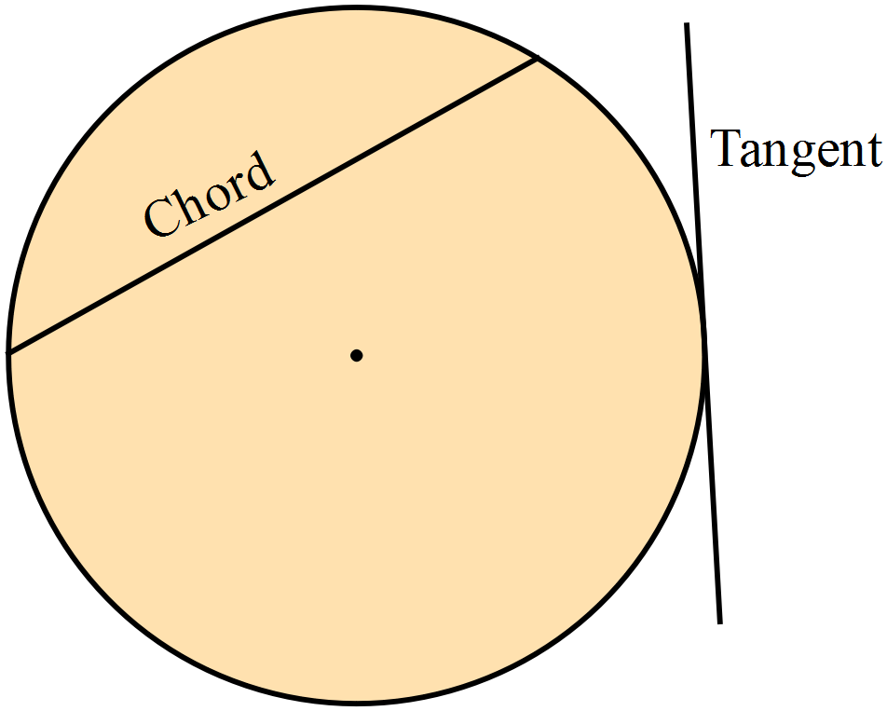 | D
 | 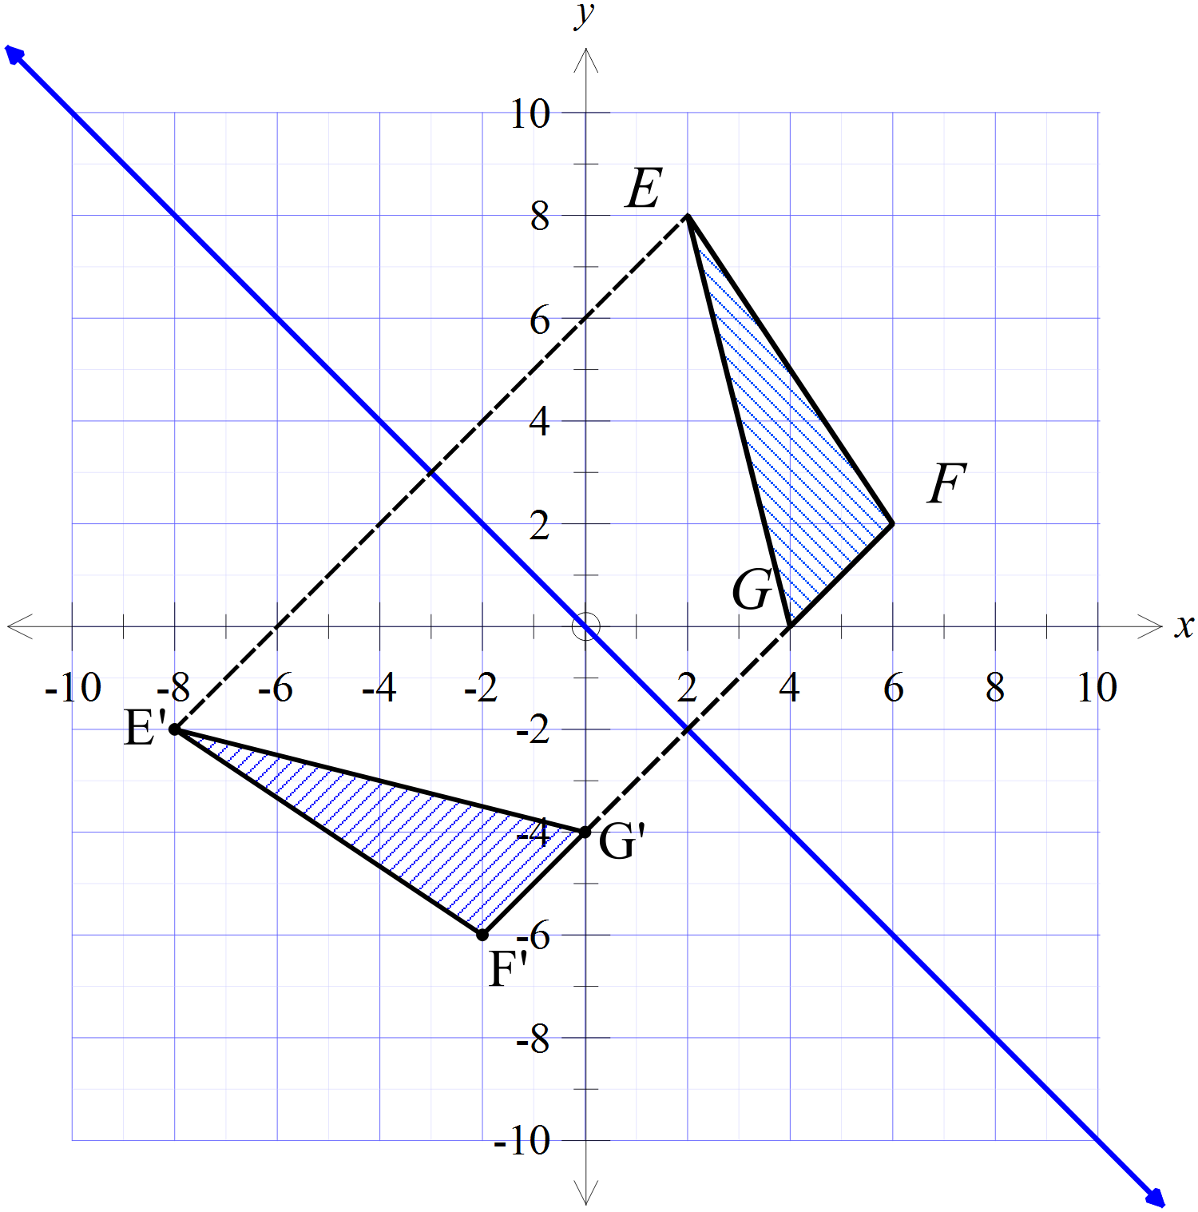  Reflection in the line 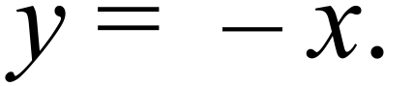 | A
 | 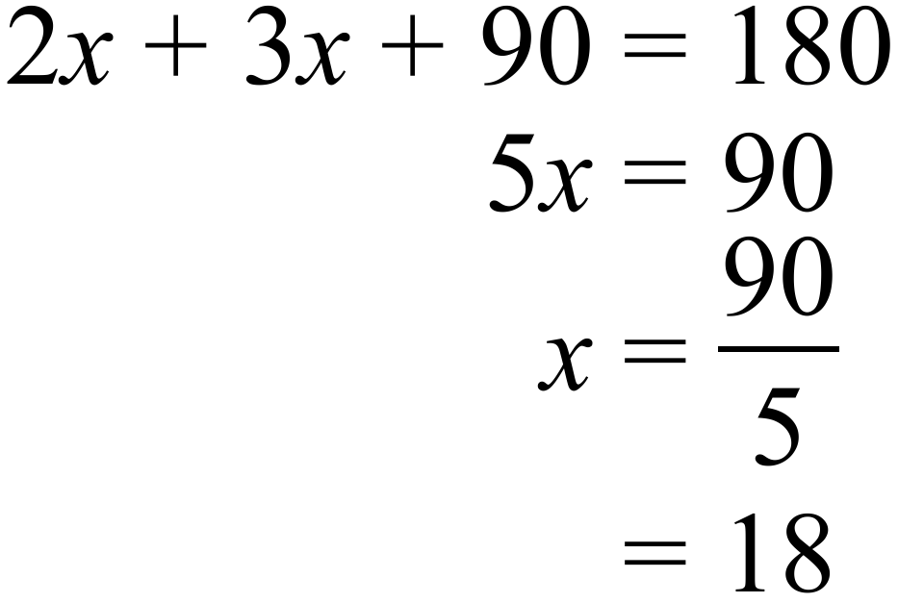 | B
 | 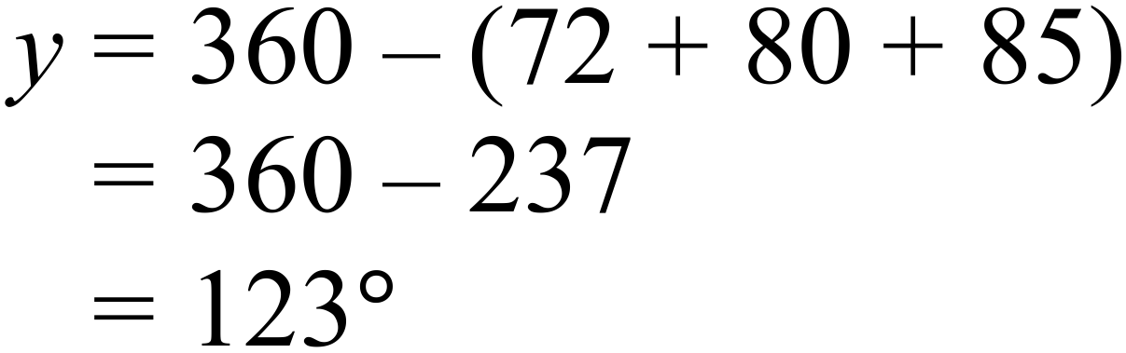 | C
 | 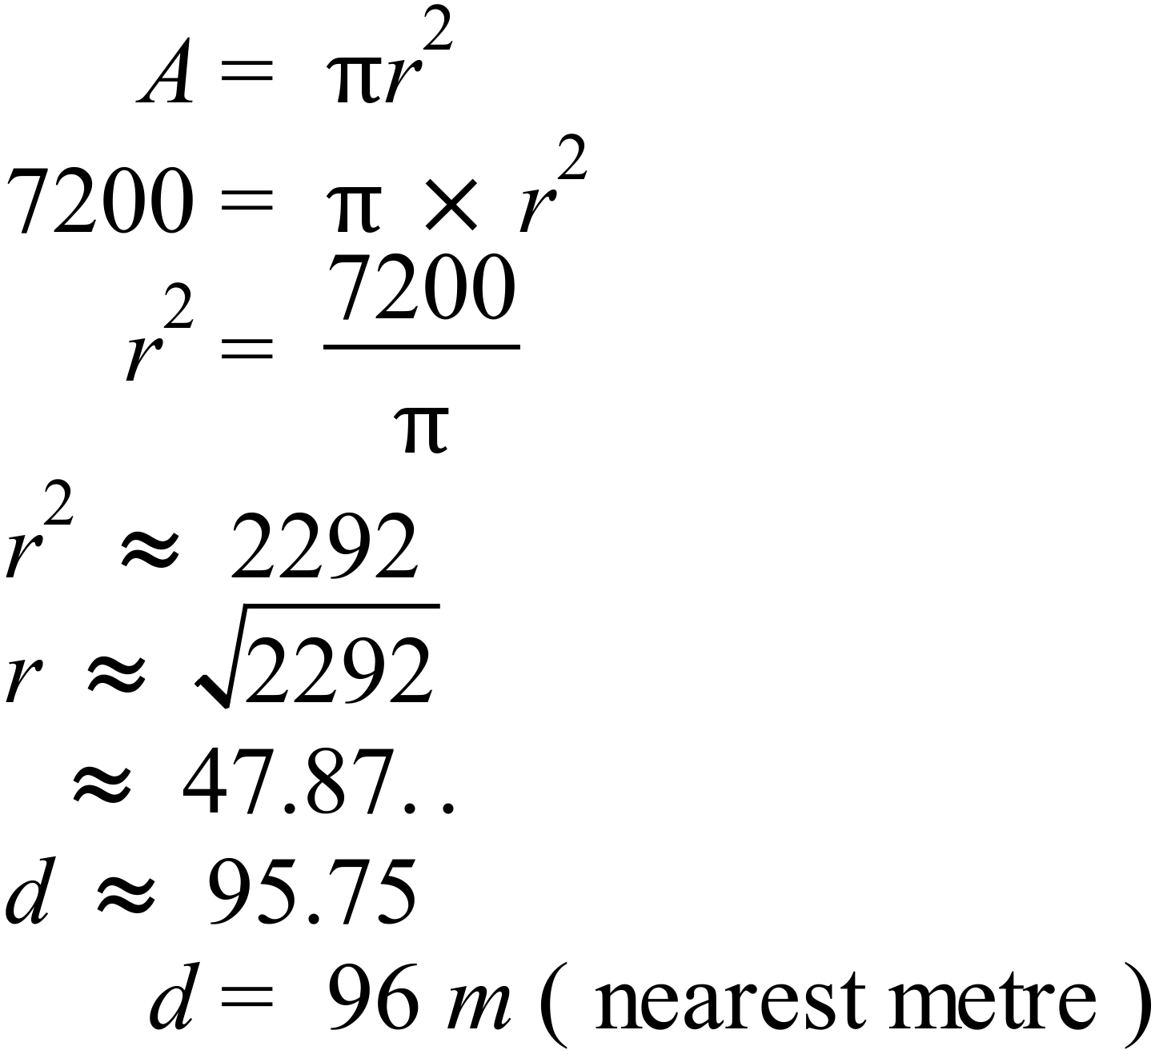  Or by testing the four alternative answers. | D
 | Diagonals of rhombus  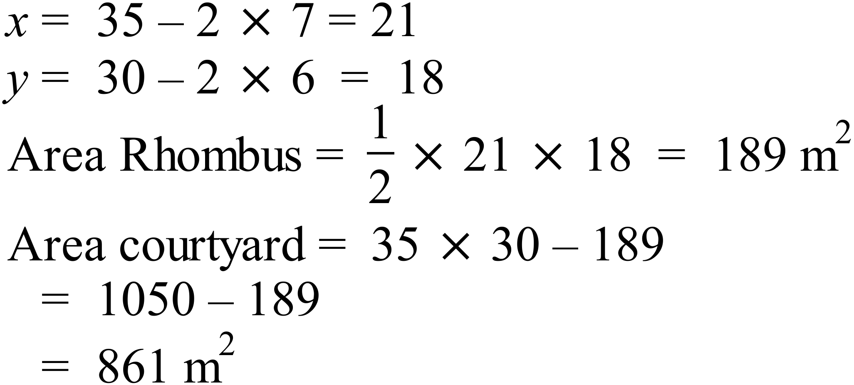 | D
 | 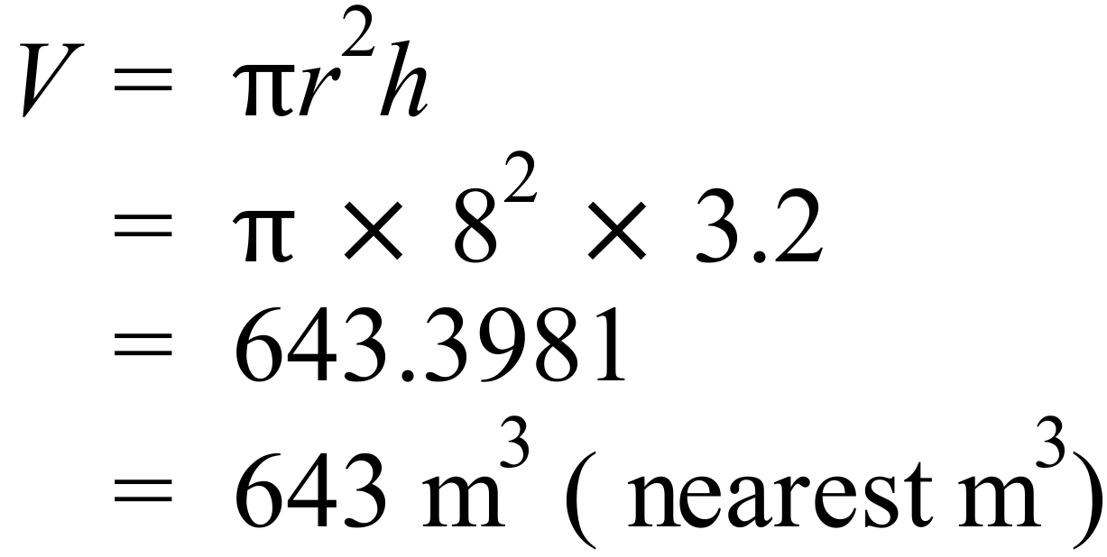 | A
 | 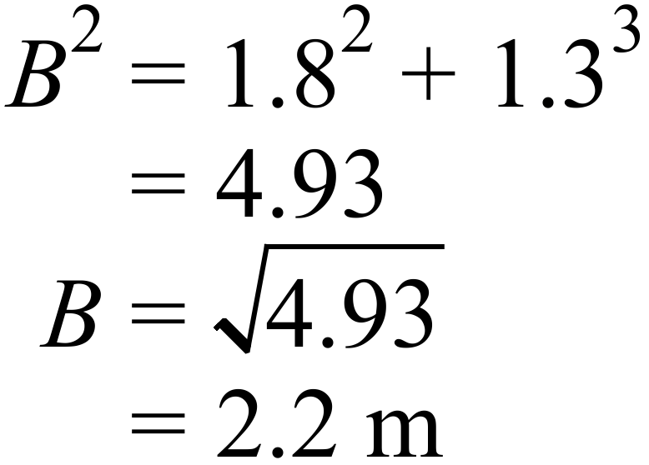 | C
 | 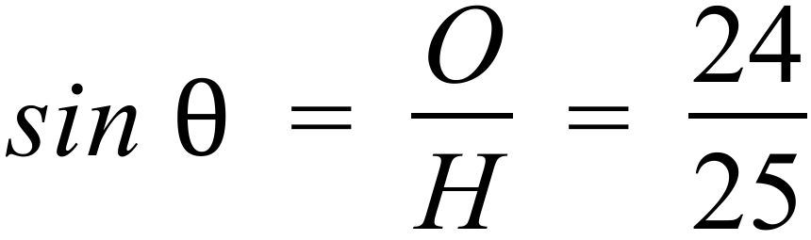 | C
 | 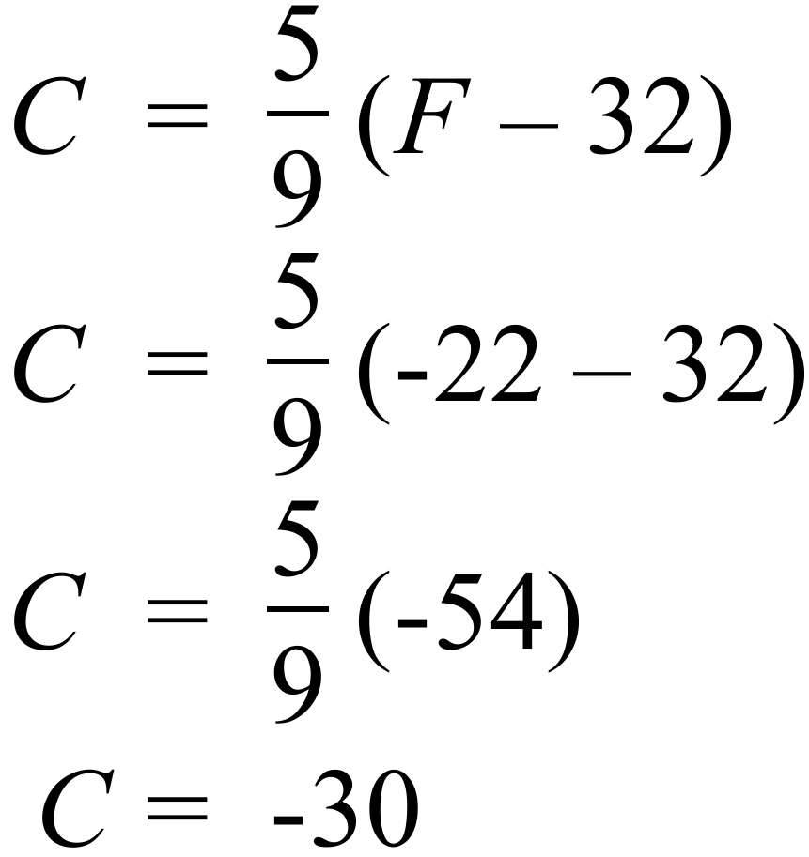 | B
 | 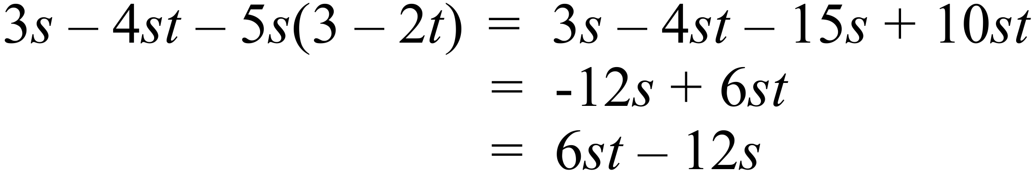 | A
 | 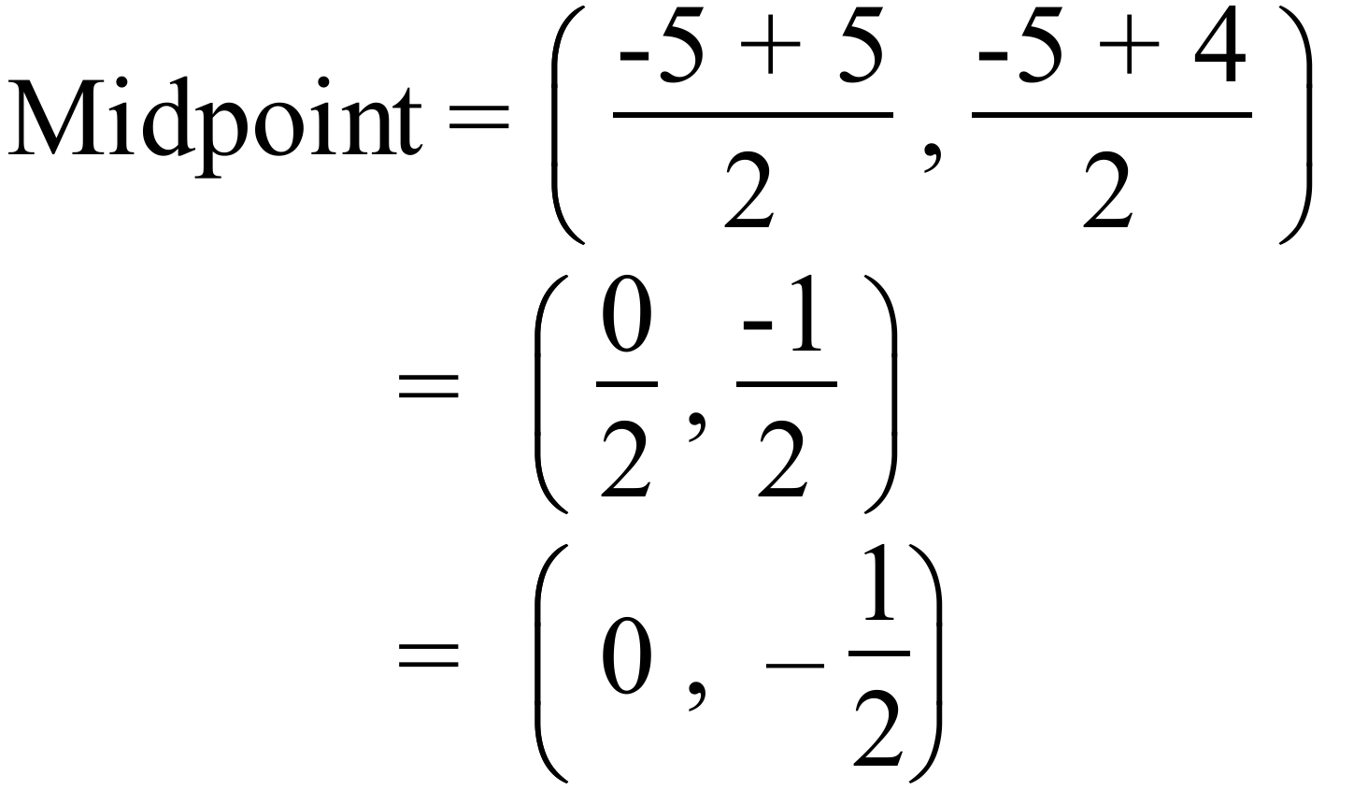 | B
 | 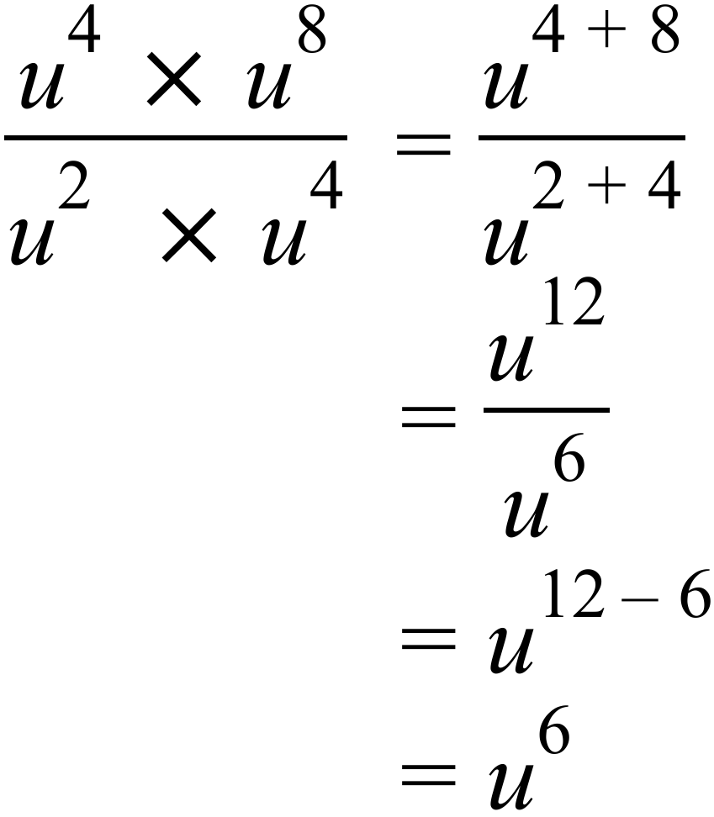 | D
 | 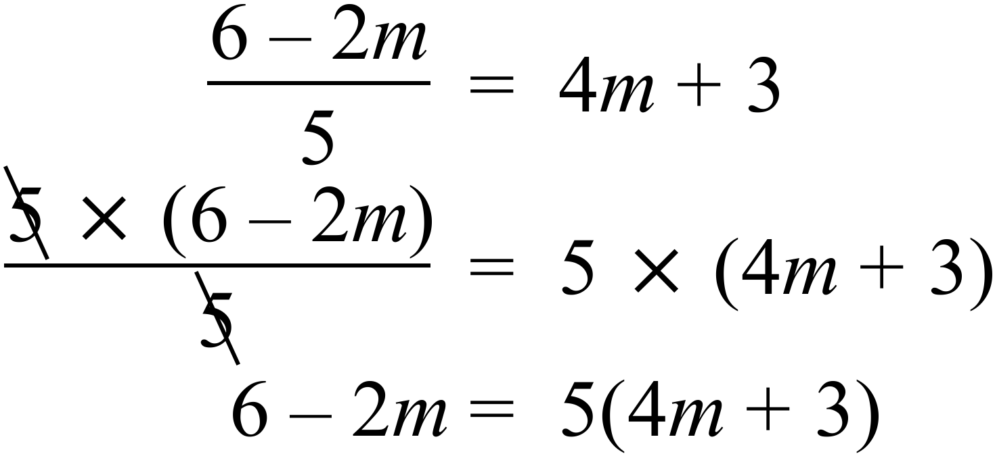 | A
 | Choosing 3 males and 4 females from her class of 28 students is a sample of the class. | B
 | 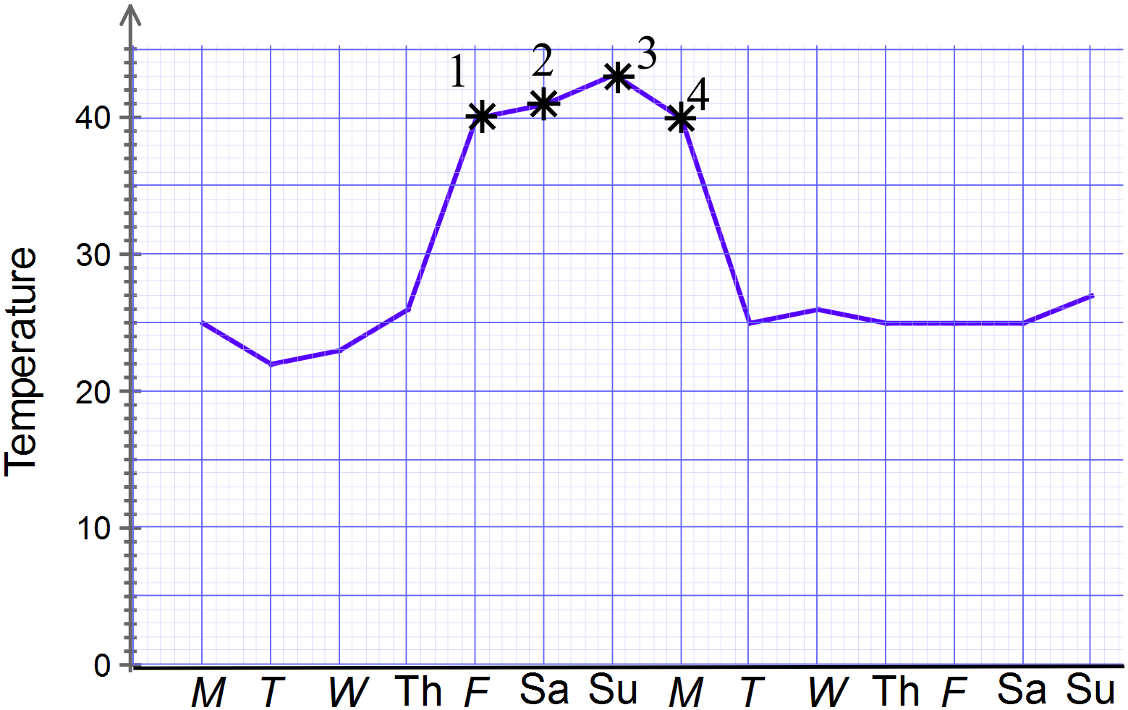  4 days at $10 per day = $40 | D
 | 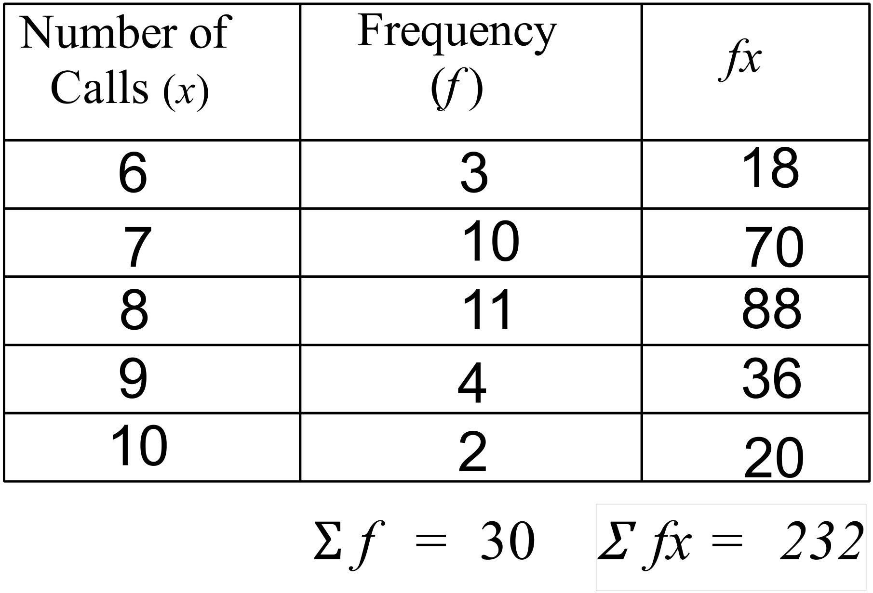  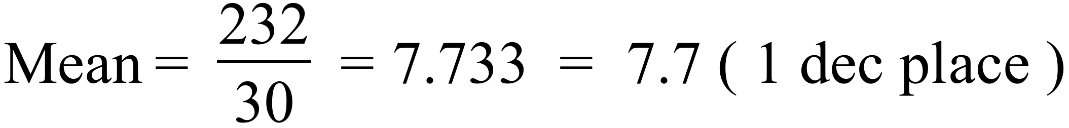 | A
 | 76 and 98 both occur three times so are both modes. | A
 | Range = 100 – 67 = 33 | C
 | ⌂ = 7 and □ = 6 | A
  7 | 4 | 5 | –
  2 | 6 | 8
  4 | 7 | 7
 | 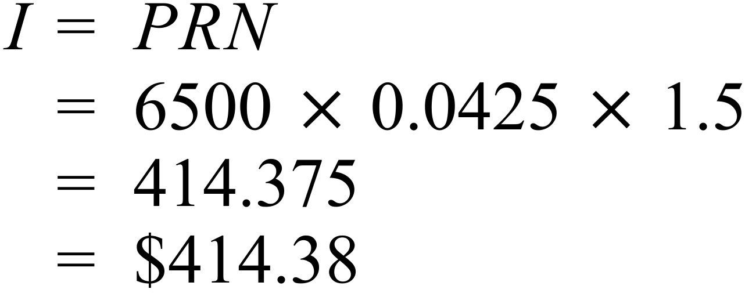 | A
 | 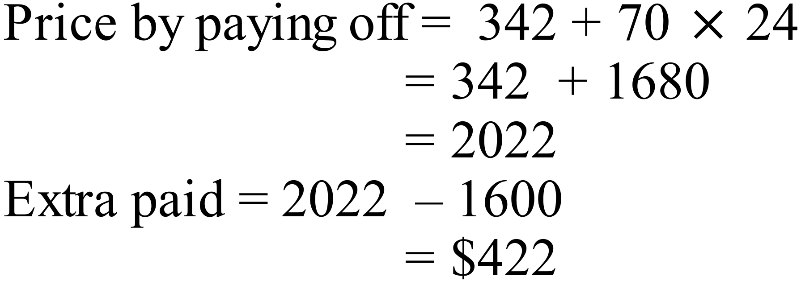 | B
 | 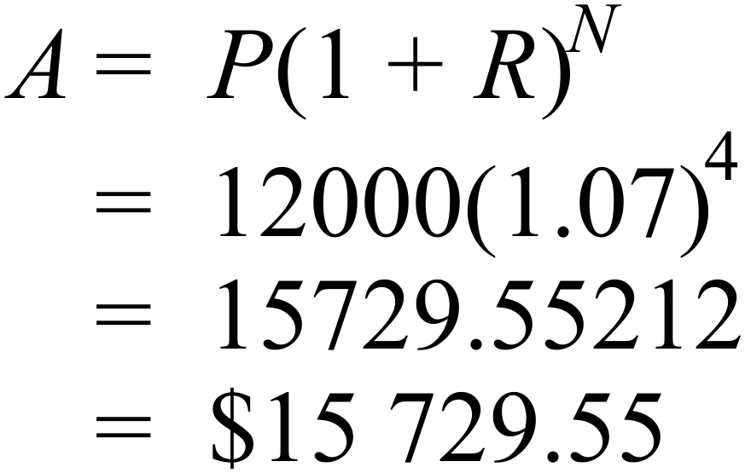 | D
 | Half is $1250.  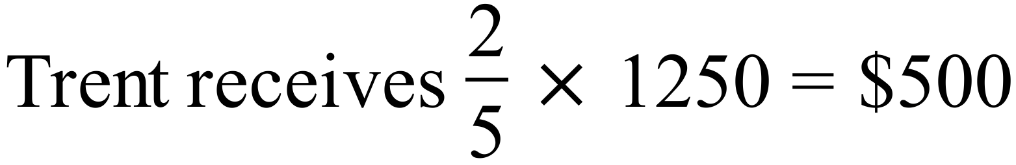 | A
 | 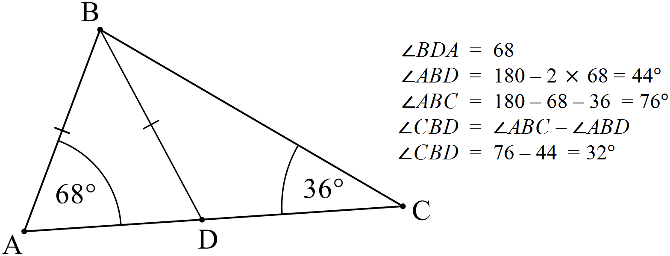 | A
 | 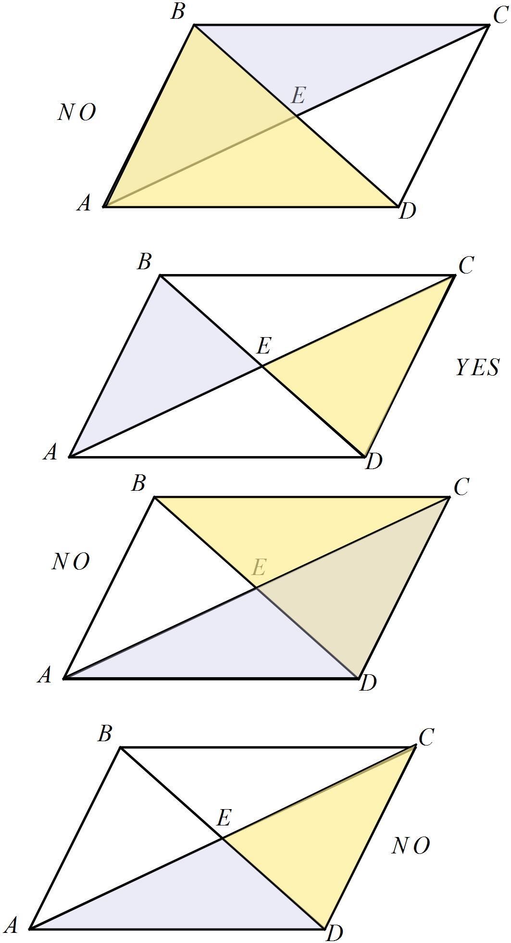  B. 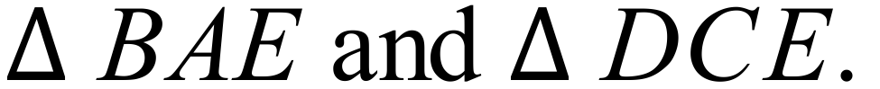 | B
 | 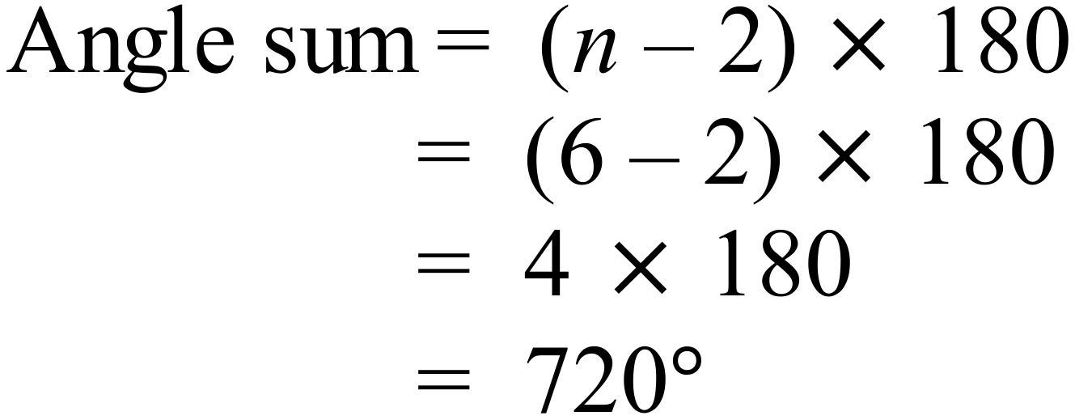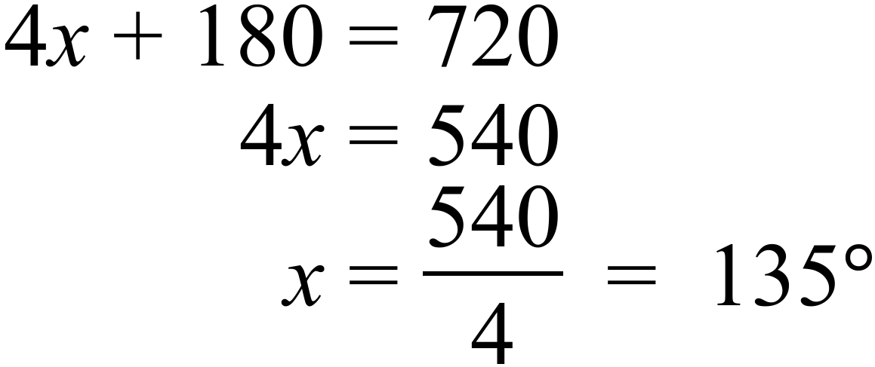 | C
 | 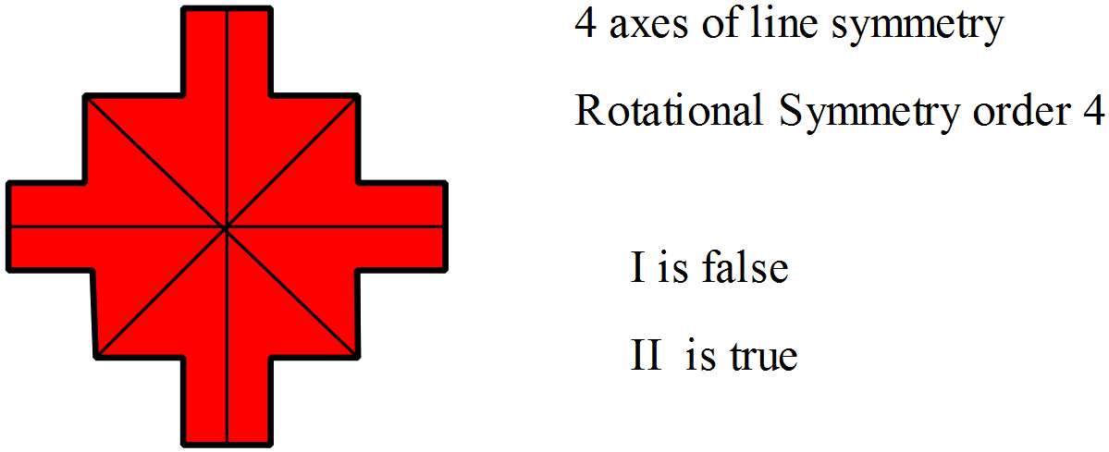 | D
 | 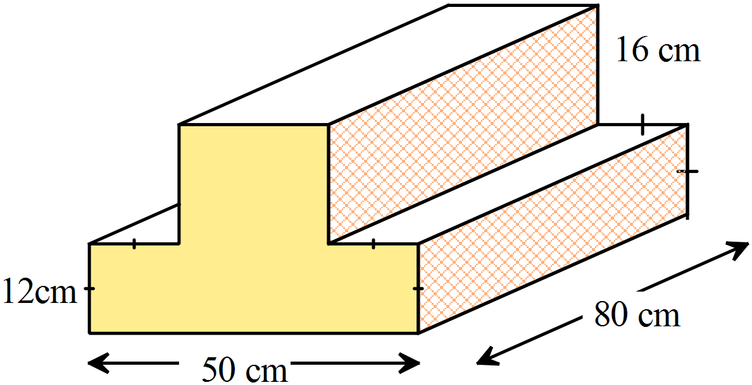  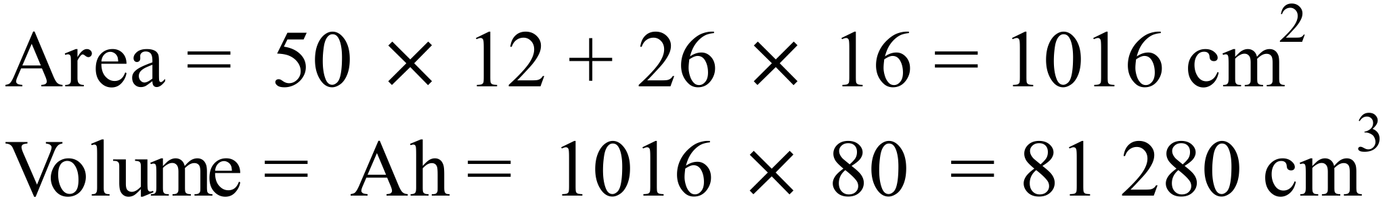 | D
 | 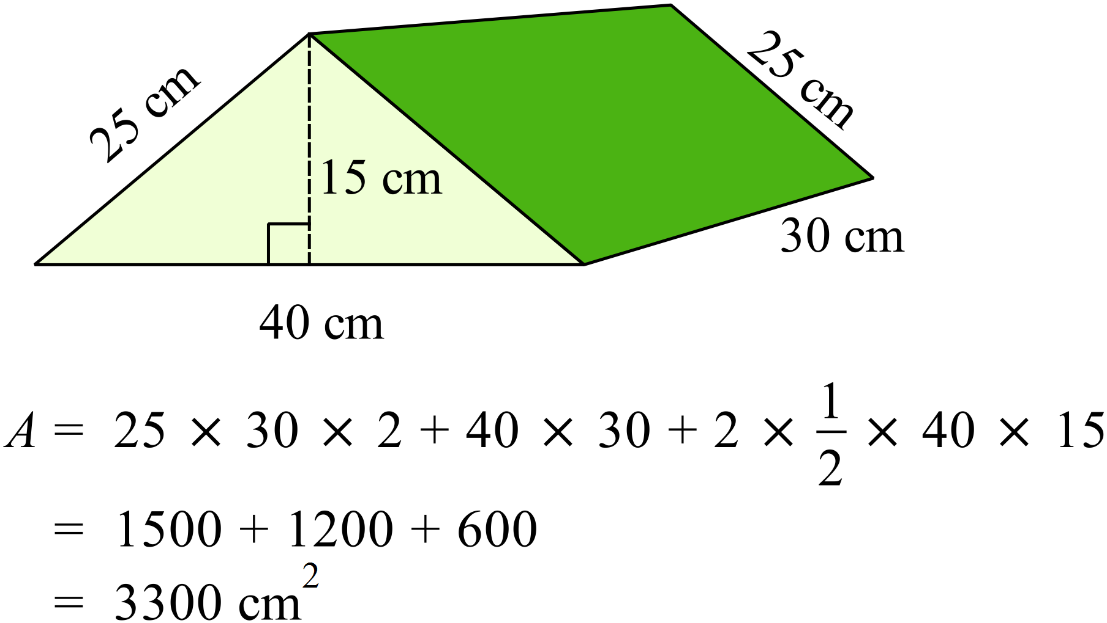 | C
 | 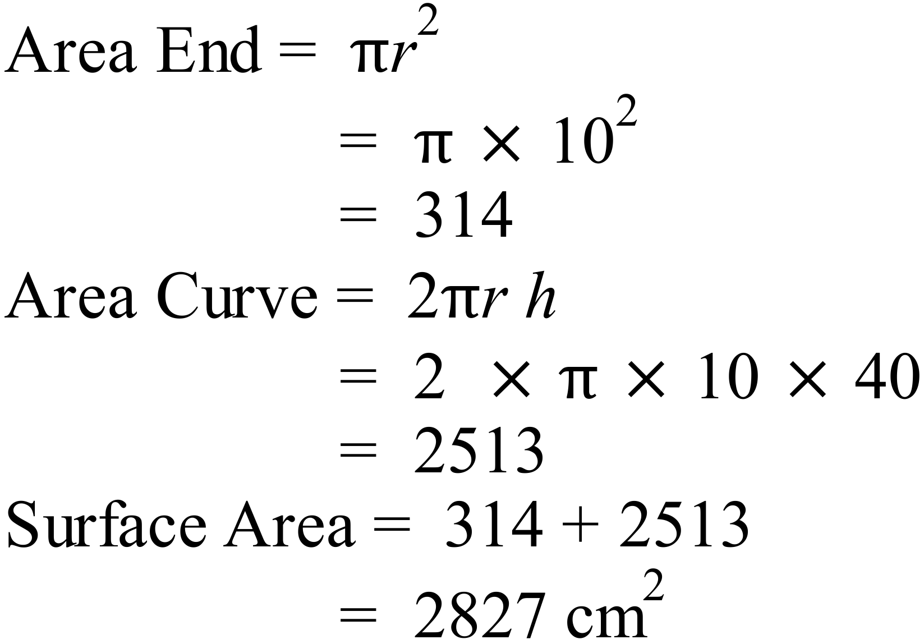 | C
 | 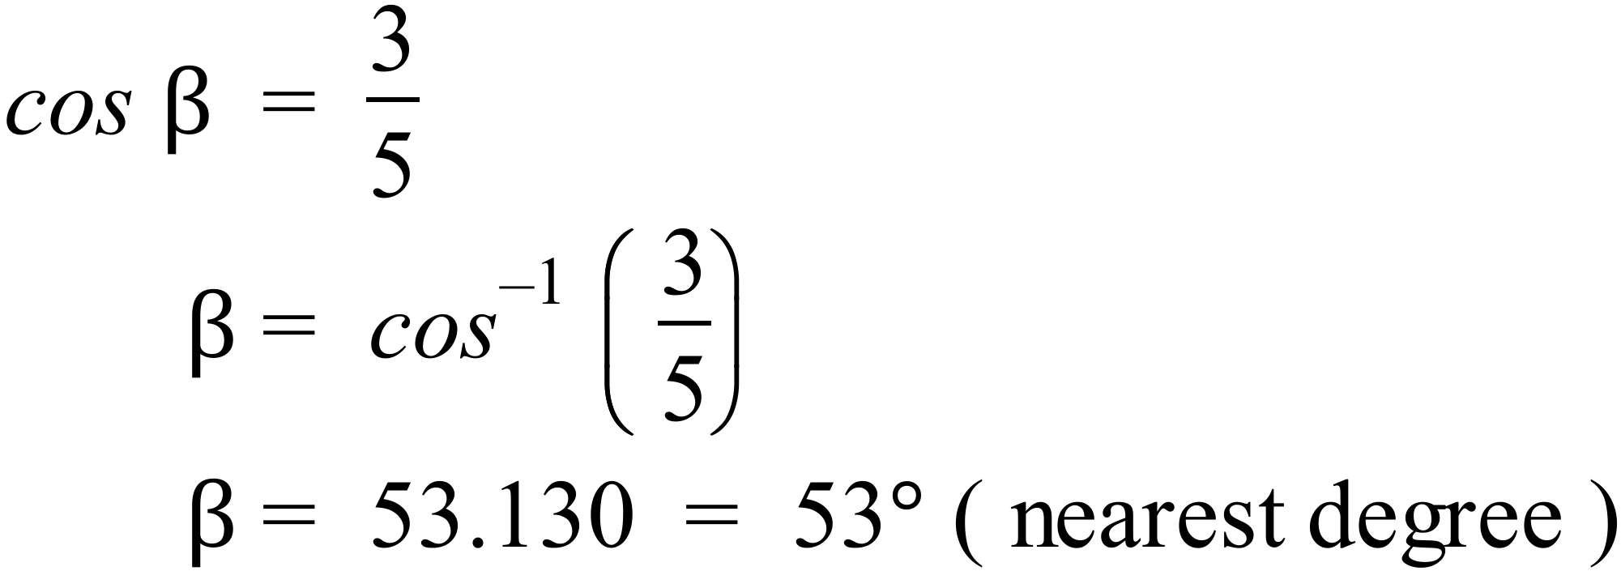 | C
 | 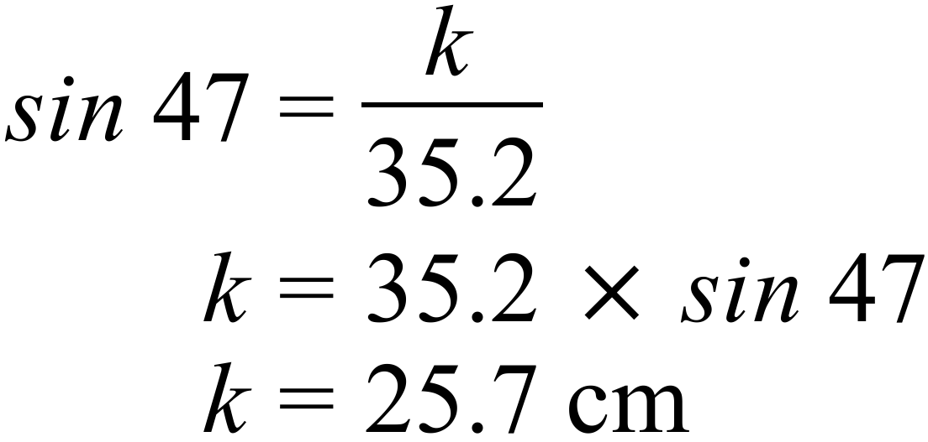 | A
 | 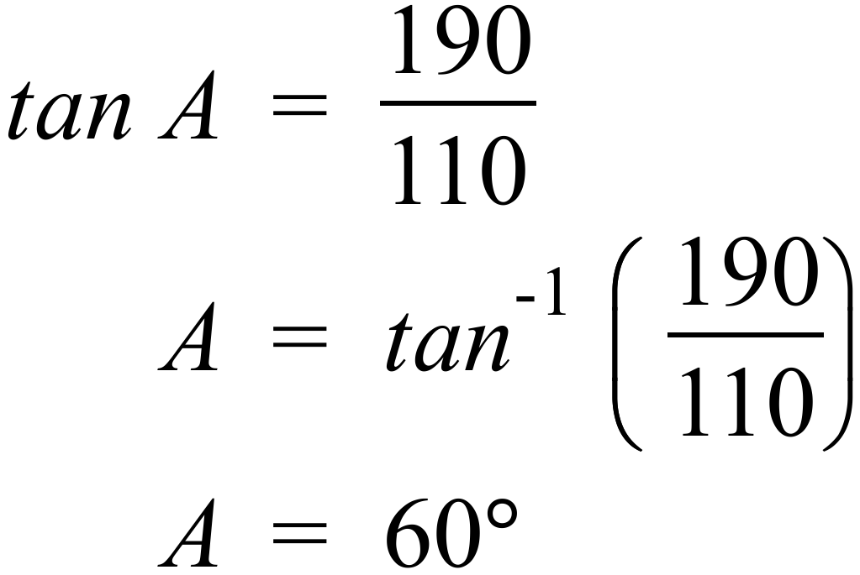 | B
 | 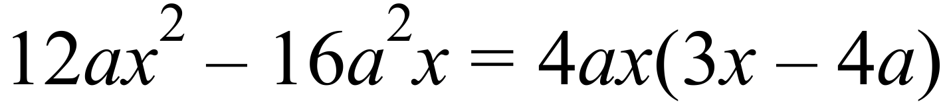  So the first three are all factors but D is not. | D
 | 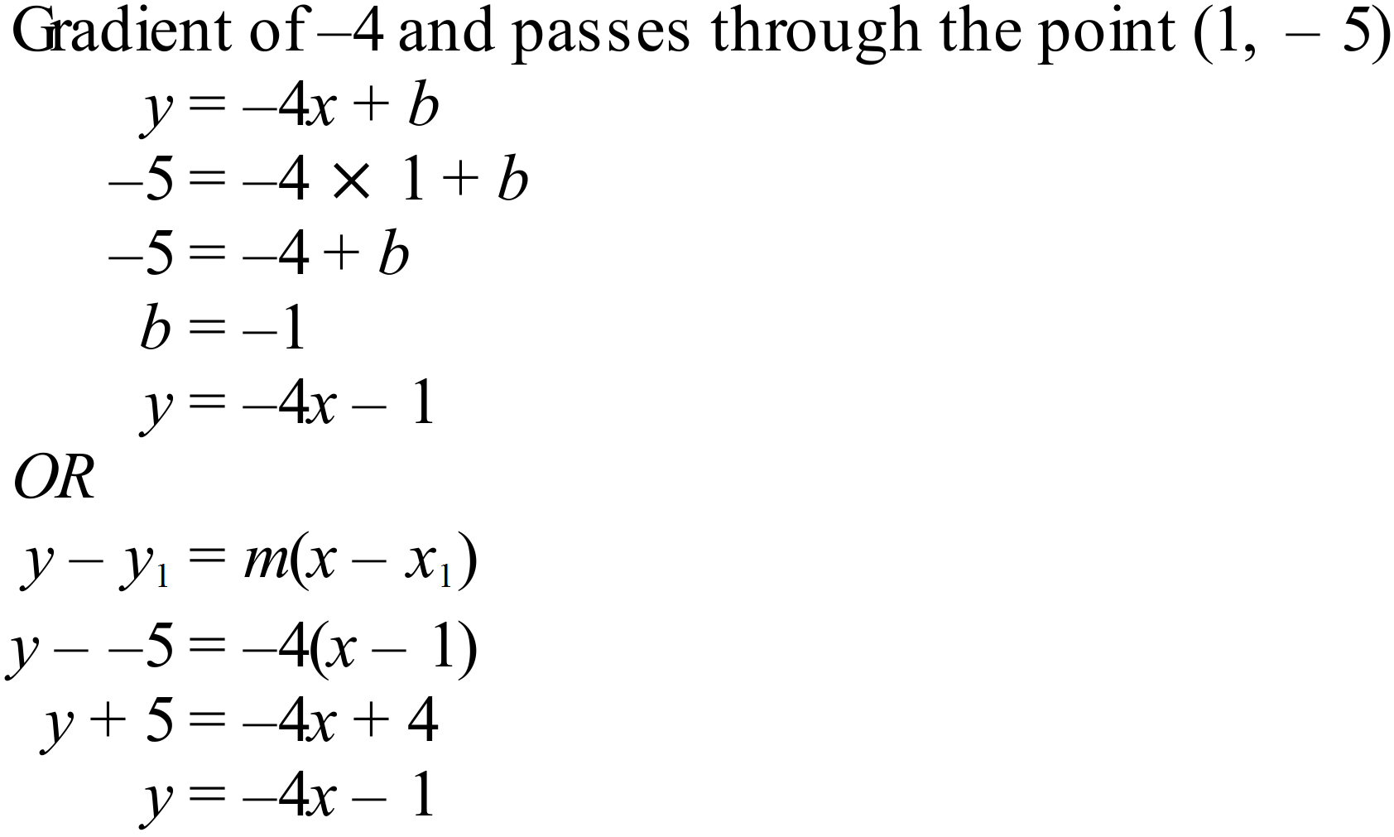 | C
 | 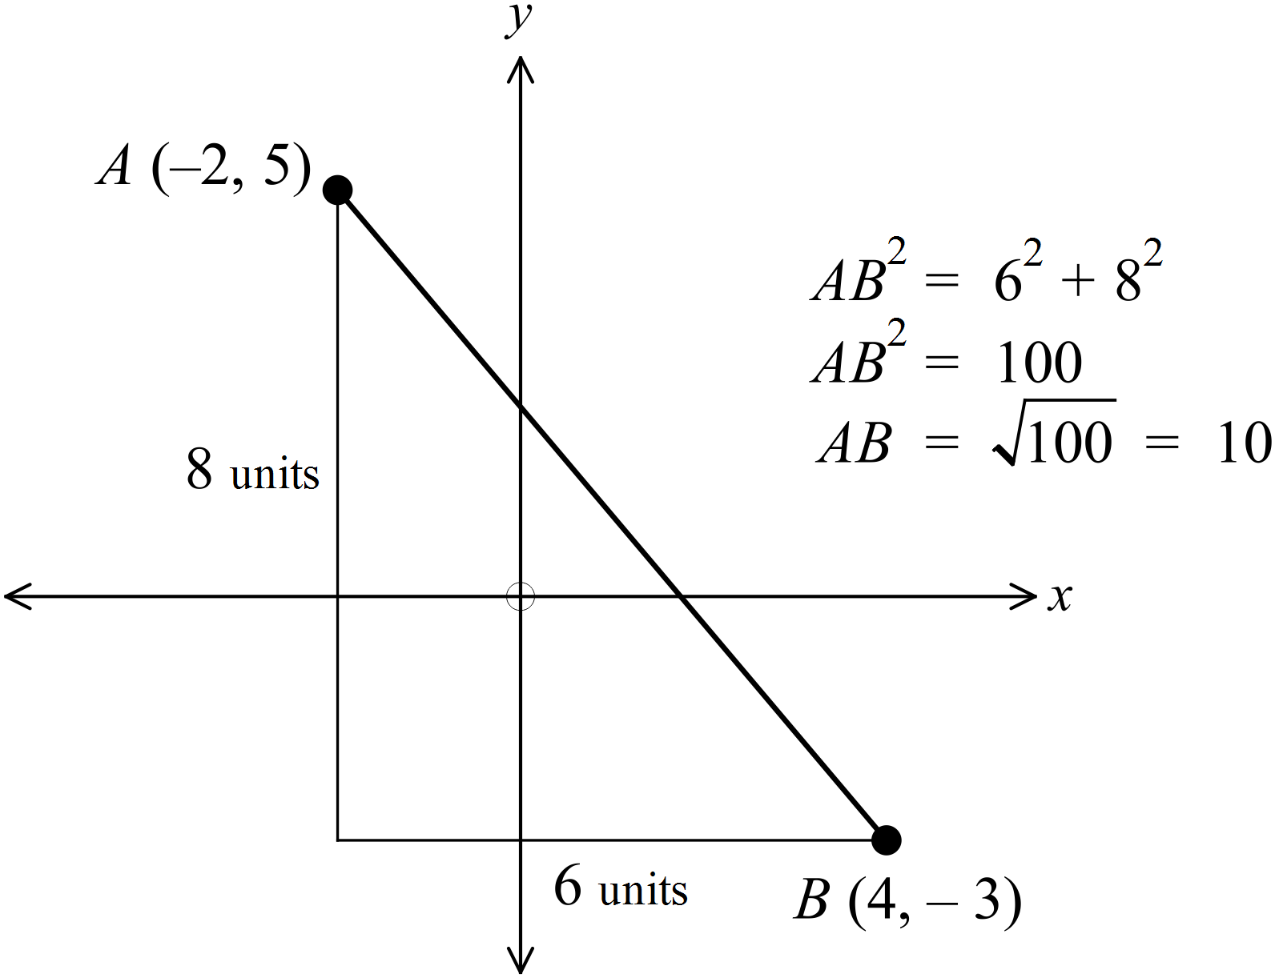 | D
 | 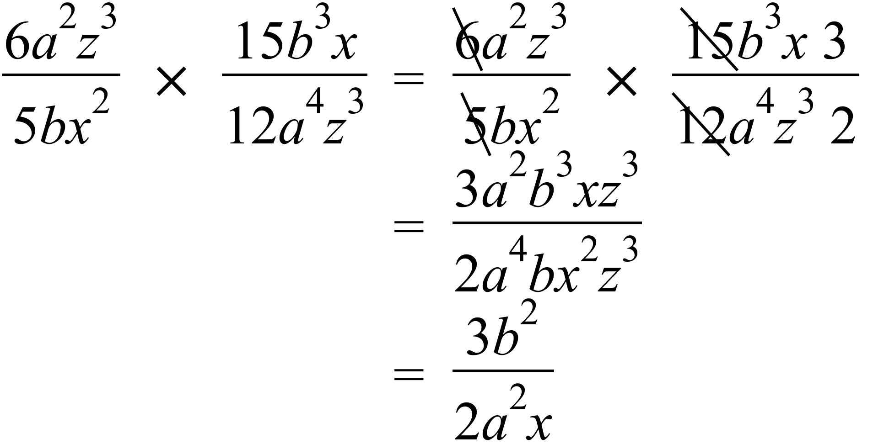 | C
 | 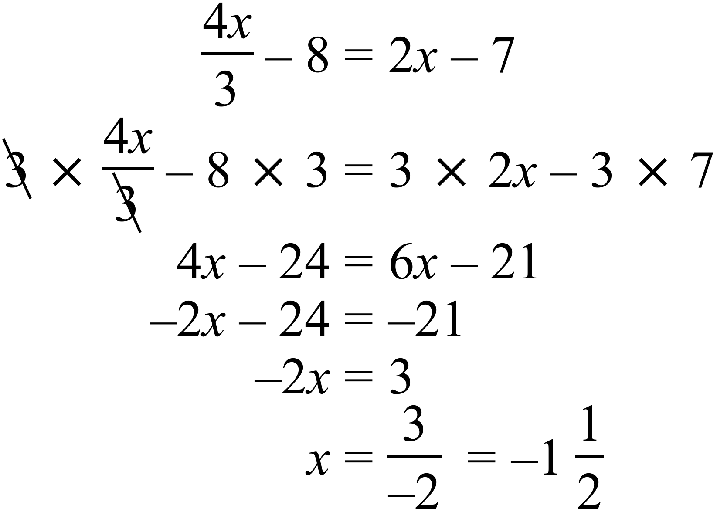 | A
Ages of Emattogah Cricket Players
1 | 4 | 5 | 6 | 6 | 8 | 9
2 | 0 | 2 | 4 | 6 | 7 | 9 | 9 | 9
3 | 1 | 3 | 4 | 5 | 5 | 7
4 | 2 | 6
5 | 3

 | Counting the leaves, there are 23. | B
 | From 23 the middle is the 12th leaving 11 above and 11 below. The 12th score is 29 | C
 | From the upper 11 scores the middle is the 6th of these leaving 5 above and 5 below, 6th from top is the 18th score which is 35. | B
 | O |  |  |  |  |  | O
 | O |  |  |  |  |  | O
 | O | O |  |  |  | O | O
O | O | O | O |  | O | O | O | O
O | O | O | O | O | O | O | O | O
1 | 2 | 3 | 4 | 5 | 6 | 7 | 8

 | It is both Bimodal (2 and 8) and symmetrical. | B
 | From observation mean = 5, median = 5,  modes = 2 and 8 and range = 9 - 1 = 8  Mean and median are equal. | C

Longer Answer Questions
76. a) | $1 grows to $1.5869 | 1 mark
b) | 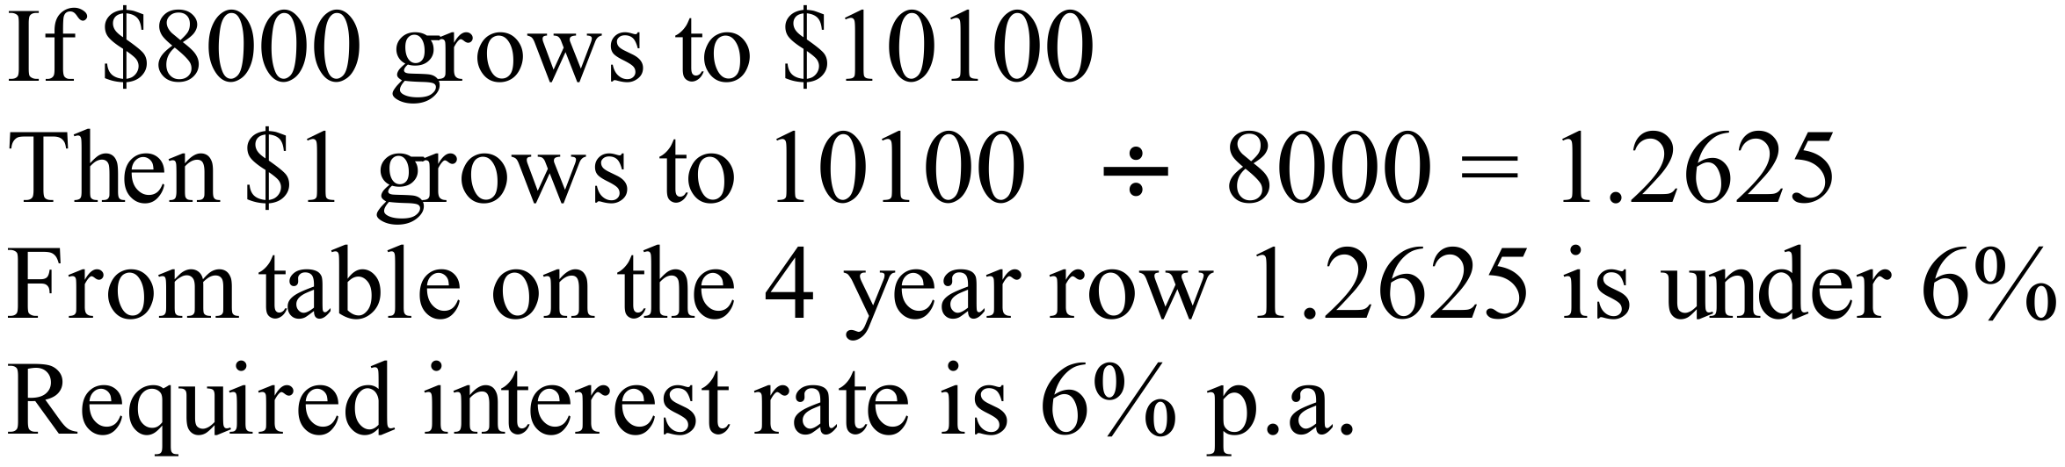 | 1 mark
c) | 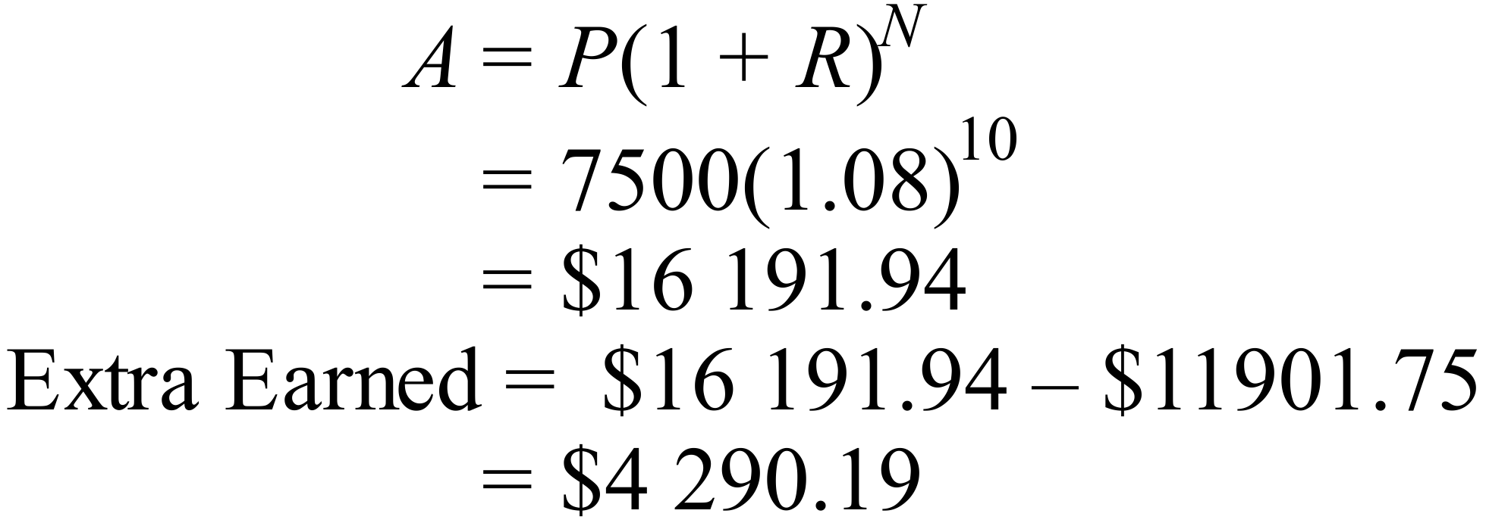 | 1 mark
77. | 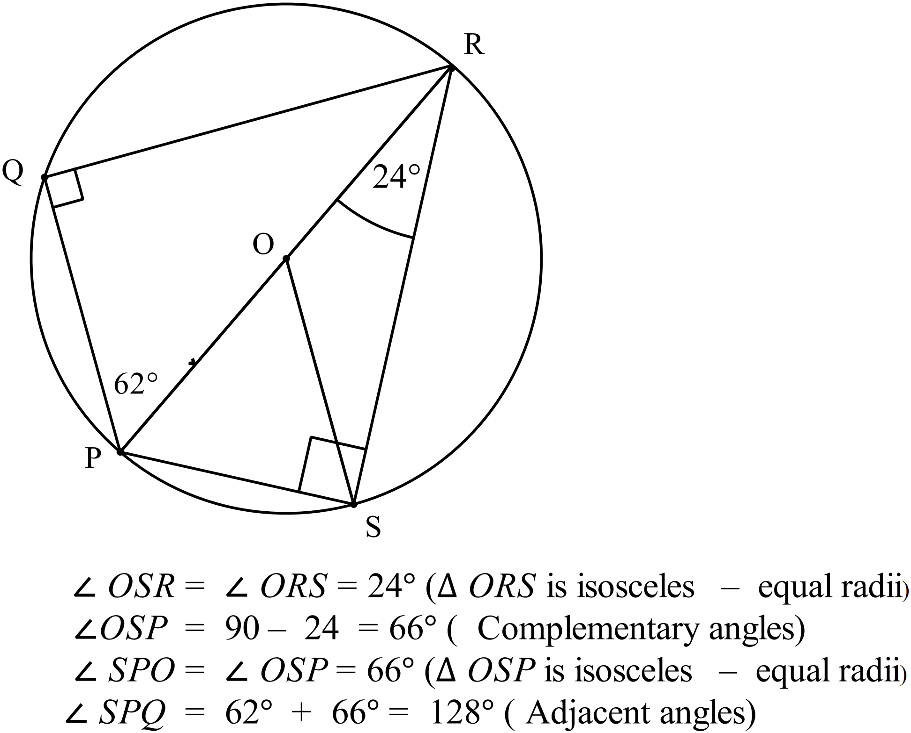 | 3 marks total  3 marks for complete answer with reasons  2 or 1 mark for partial attempts
78. a) | 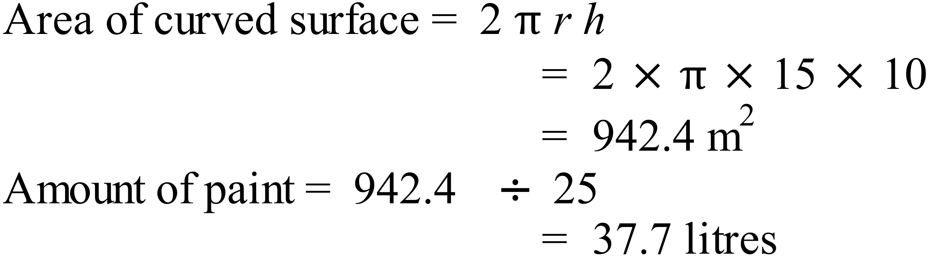 | 2 marks total  1 for area  1 for amount of paint
b) | 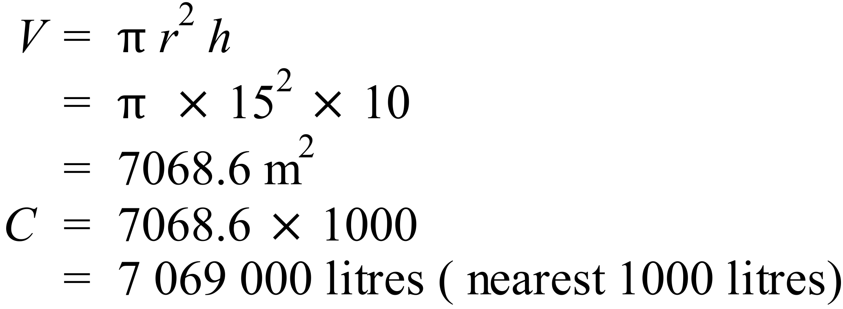 | 1 mark
79. a) | 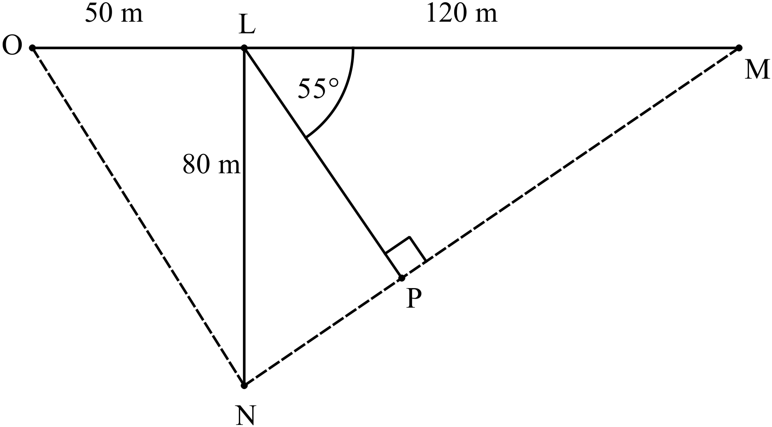  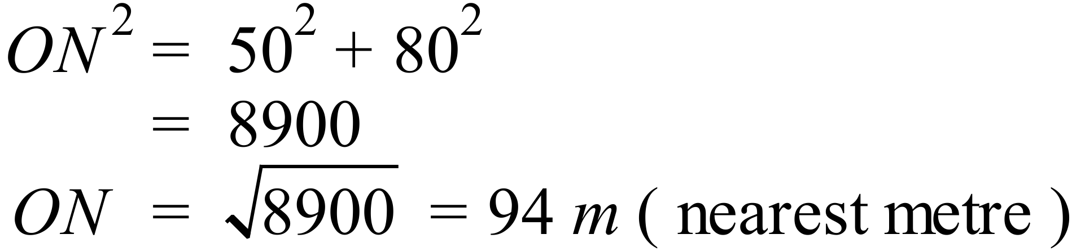 | 1 mark
b) | 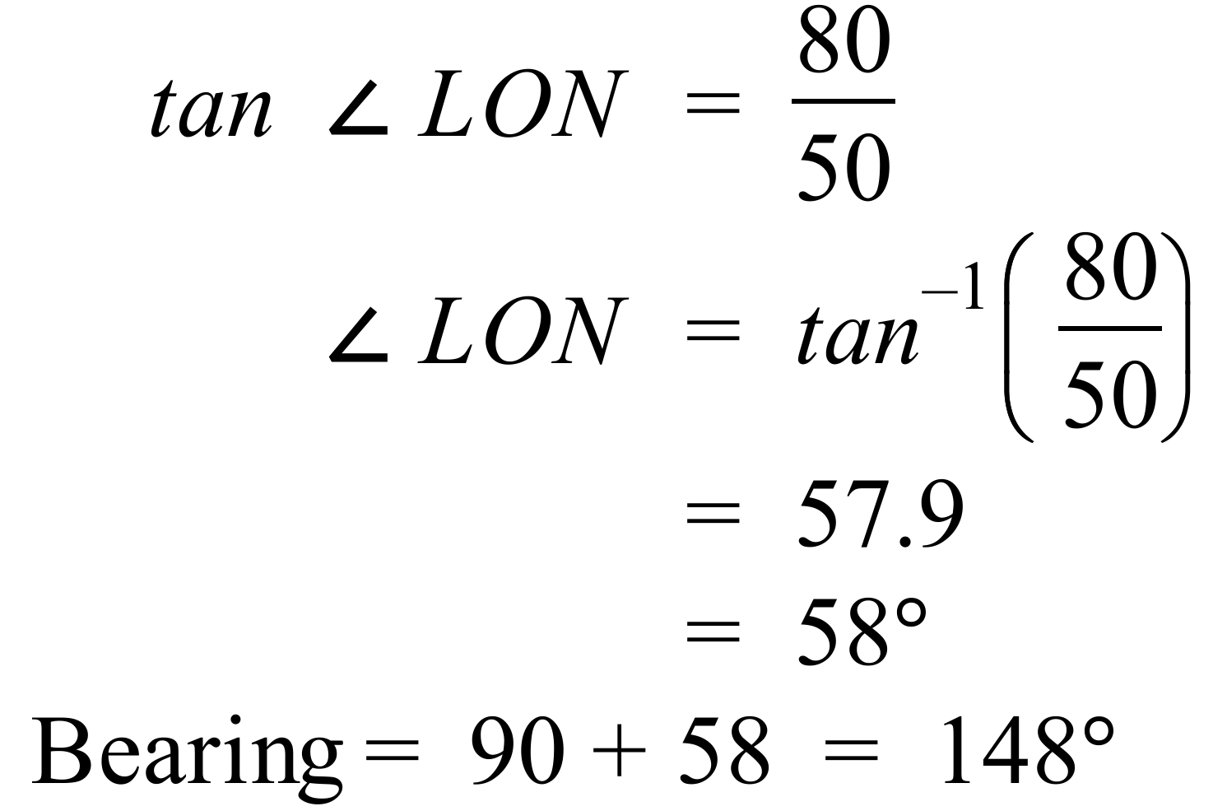 | 2 marks total  1 for angle  1 for bearing
c) | 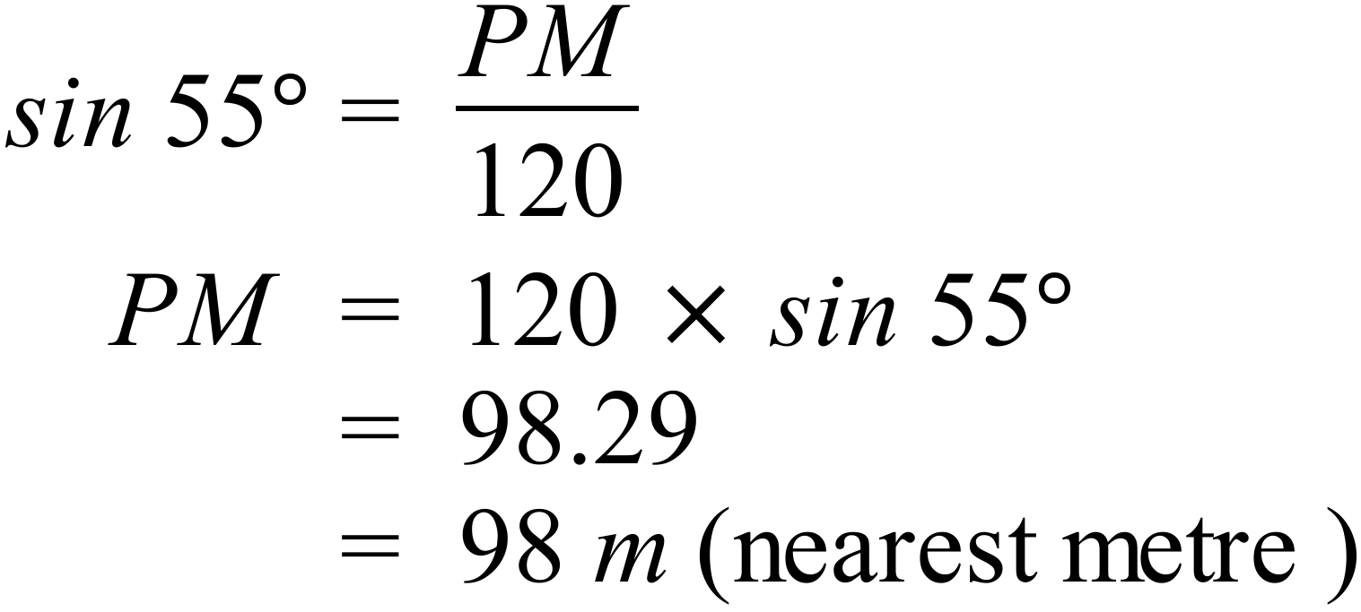 | 1 mark
80. a) | 4, 6, 8 and 12 are on black segments.  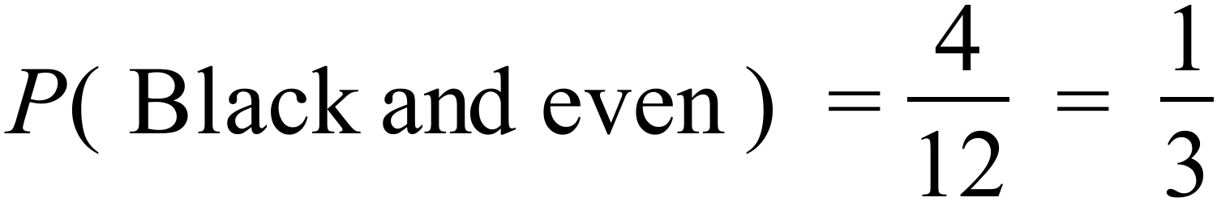 | 1 mark
b) | 1, 2, 3, and 4 are less than 5.  4, 5, 6, 7, 8 and 12 are on black segments.  4 is on both lists so only count it once, so required numbers are 1, 2, 3, 4, 5, 6, 7, 8 and 12.  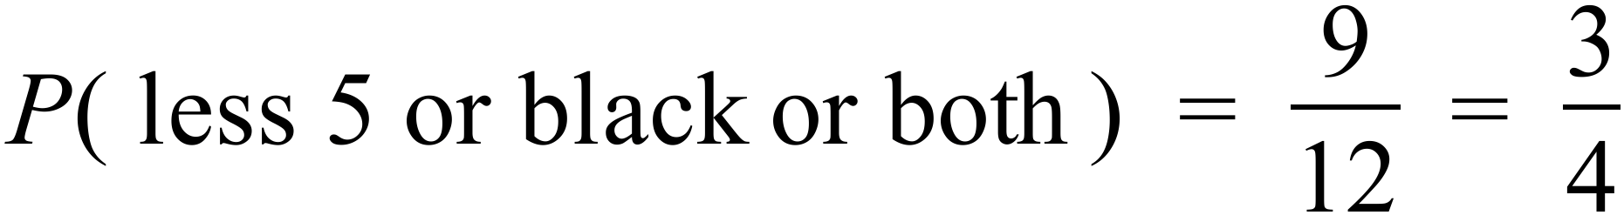 | 1 mark
81 a) | 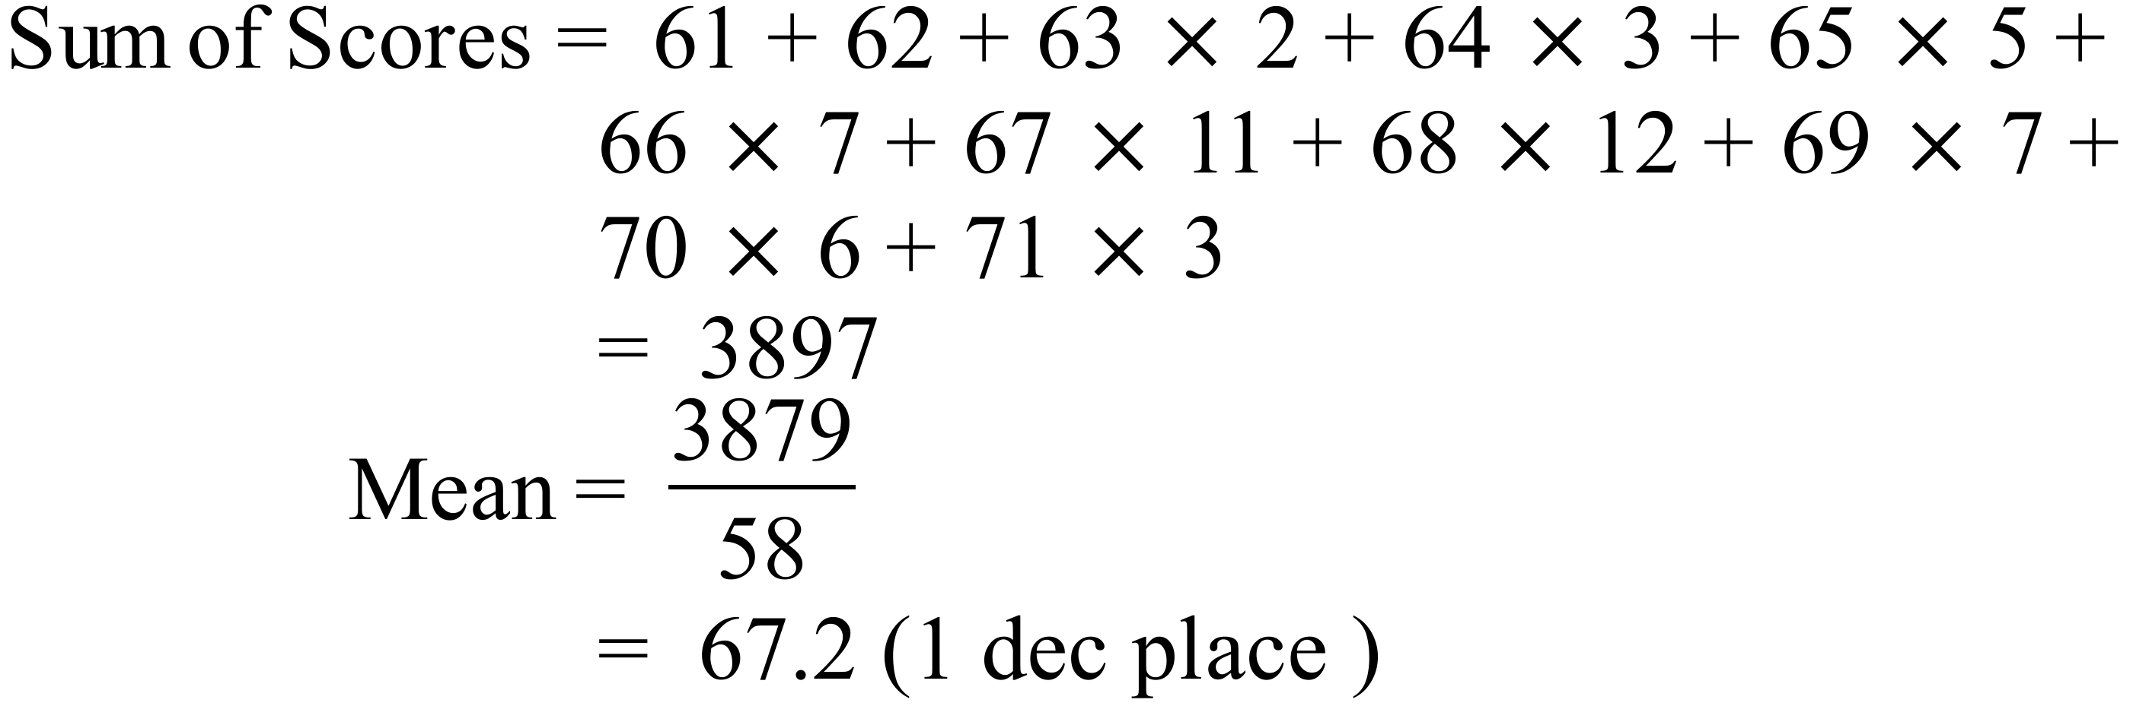 | 1 mark
b) | Both Rounds have skewed distributions but in reverse to one another. Round 1 is skewed toward the higher scores and round 2 is skewed toward the lower scores. Round 1 would have a higher mean and median than Round 2. | 2 marks total  2 marks for a description that correctly mentions different skew and relative value of the means/ medians.  1 if one of these is mentioned correctly.
82. a) | 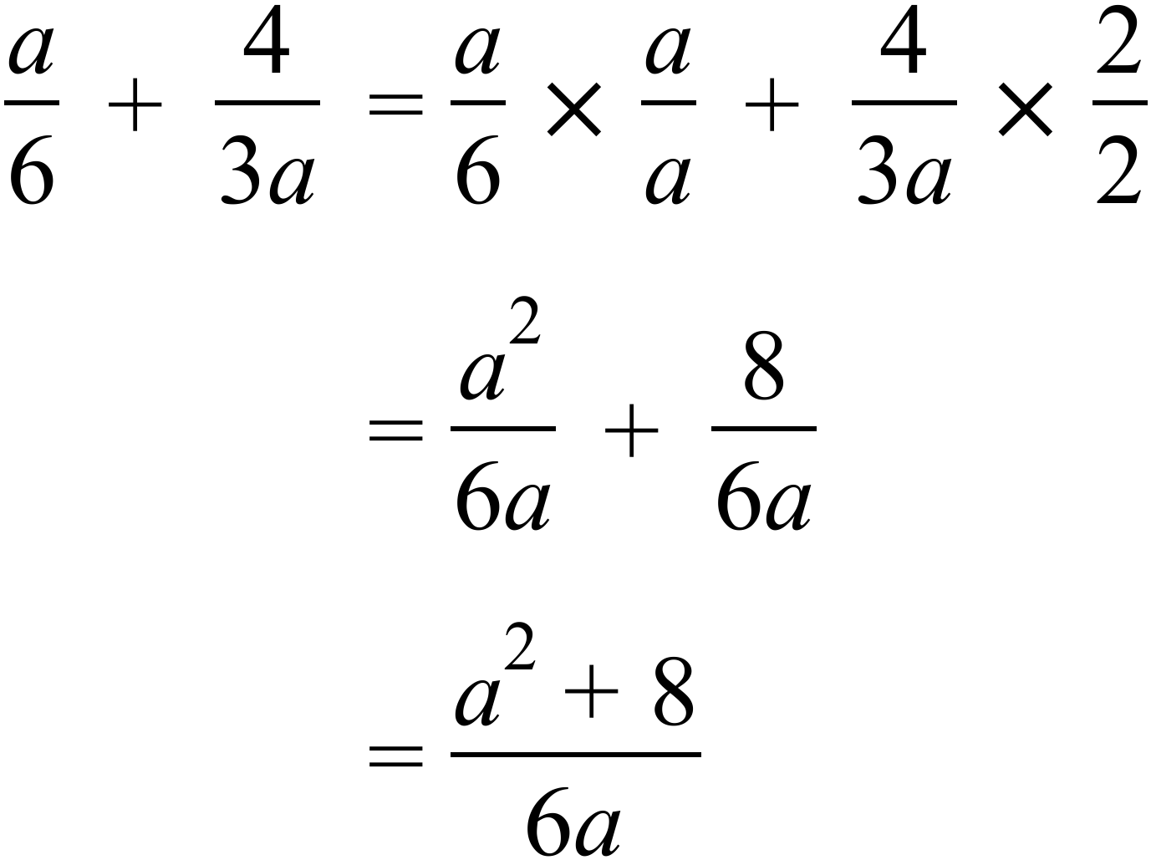 | 2 marks total  2 marks for correct answer  1 for some correct working with a minor error
b) | 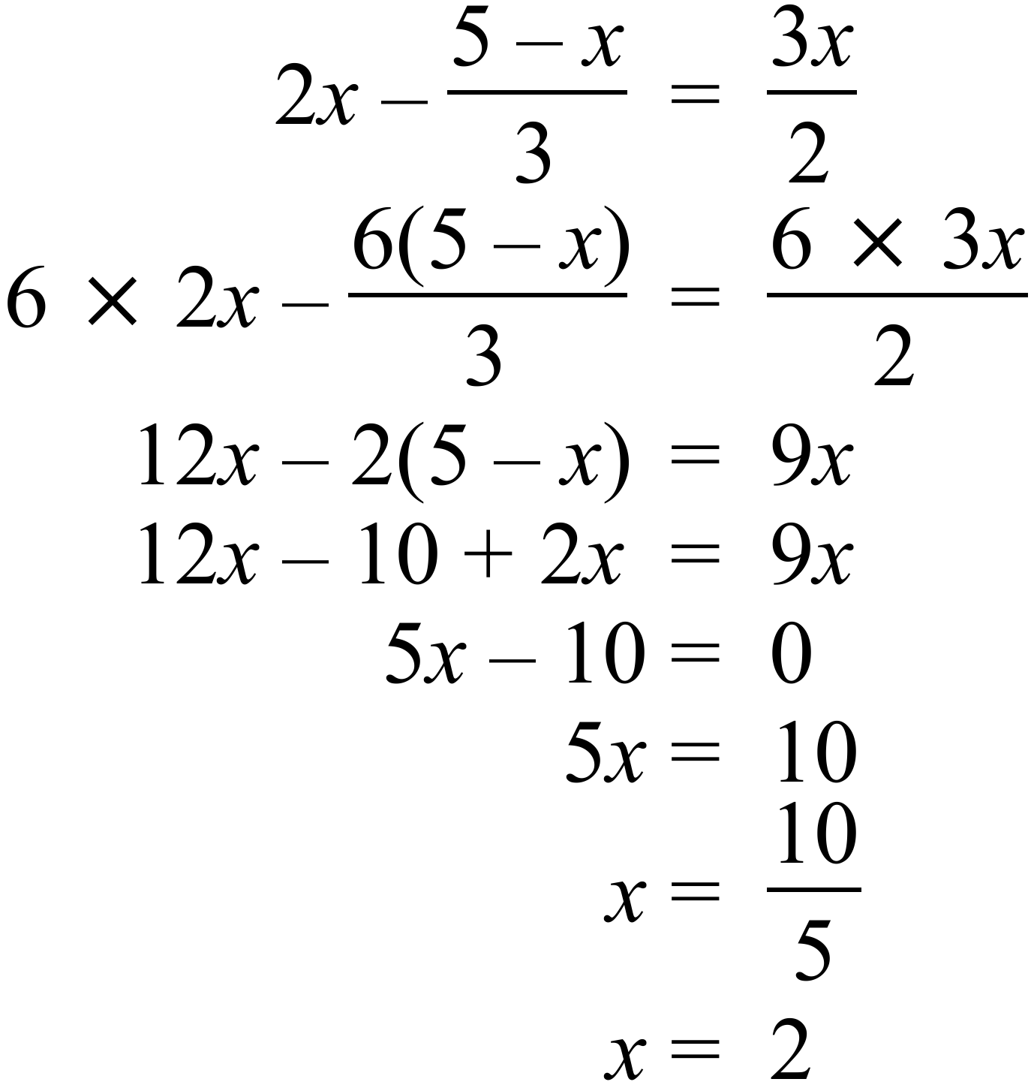 | 2 marks total  2 marks for correct solution  1 for some correct working with an error
83. | 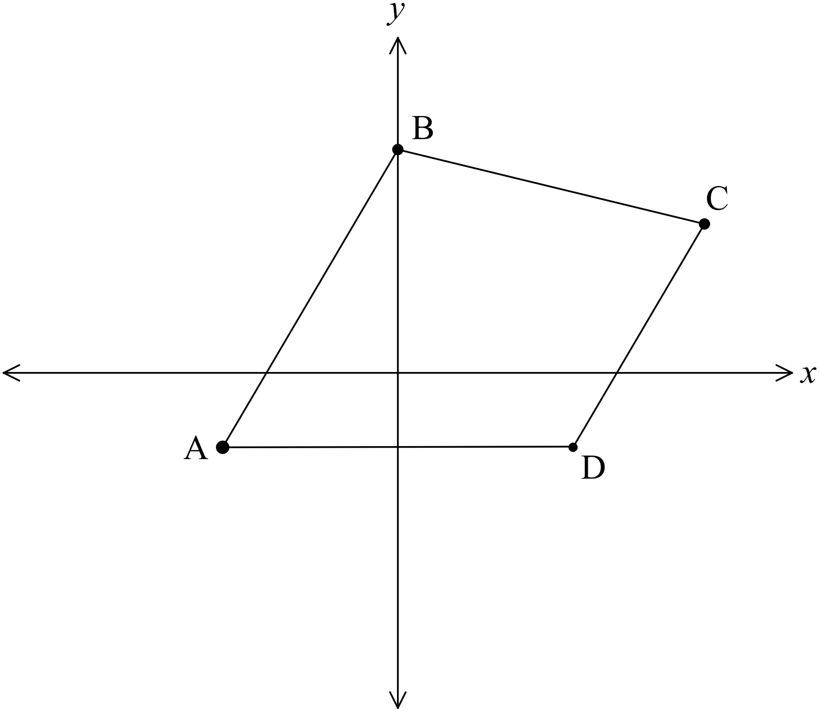  AB and CD appear parallel.  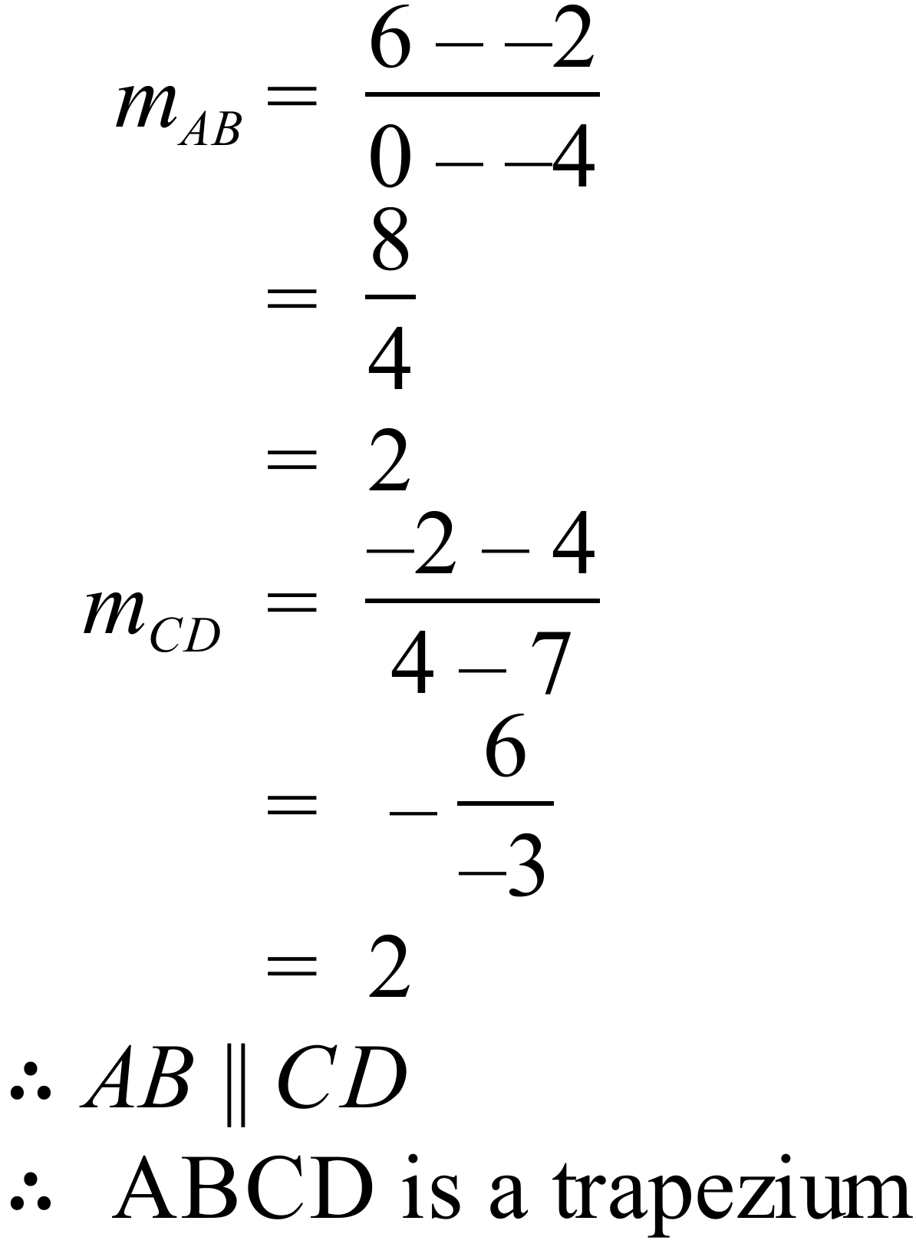 | 3 marks total  1 gradient  1 gradient  1 conclusion

High School
Half - Yearly Exam
Mathematics Course
Multiple Choice Section Answer Sheet
Name ____MARKING SHEET Teacher ________________________
Completely fill the response oval representing the most correct answer.

26. A B C D
27. A B C D
28. A B C D
29. A B C D
30. A B C D
31. A B C D
32. A B C D
33. A B C D
34. A B C D
35. A B C D
36. A B C D
37. A B C D
38. A B C D
39. A B C D
40. A B C D
41. A B C D
42. A B C D
43. A B C D
44. A B C D
45. A B C D
46. A B C D
47. A B C D
48. A B C D
49. A B C D
50. A B C D

51. A B C D
52. A B C D
53. A B C D
54. A B C D
55. A B C D
56. A B C D
57. A B C D
58. A B C D
59. A B C D
60. A B C D
61. A B C D
62. A B C D
63. A B C D
64. A B C D
65. A B C D
66. A B C D
67. A B C D
68. A B C D
69. A B C D
70. A B C D
71. A B C D
72. A B C D
73. A B C D
74. A B C D
75. A B C D

